Indian Institute of Management (IIM), Rohtak
Batch PGP-17

Subject: Written Analysis of Communication
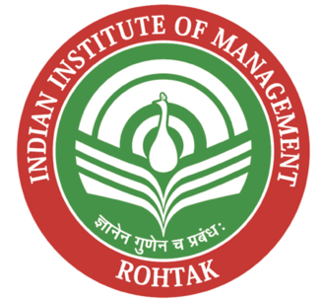

Term -I
Submitted By:
Anant Mishra - IPM05153
Kunal Khanna - PGP17063
Siddhi Vinayak Vaidya - PGP17074
Simran Sahu – PGP17096
Somya Jeet – PGP17097
Sourav Ganguly – PGP17075
Section: B
Date of Submission: August 14, 2026
Submitted To: Ms. Pritima Kaushal

Topic: Sustainable Development Goal 4 - Quality Education

Letter of Transmittal

26 August 2026
Prof. Pritima Kaushal
Faculty, Written Analysis and Communication
Indian Institute of Management Rohtak
Respected Ma'am,
Subject: Submission of the group report on communicating SDG 4 to company stakeholders
We are submitting our report titled Communicating United Nations Sustainable Development Goal 4: Quality Education to All Stakeholders of Vidyanta Learning Private Limited. This report follows the format that was shared for the assignment. It focuses on an industry, a hypothetical company, the connection, with SDG 4 the progress that has been made so far a three-year plan and a corporate communication strategy that covers both internal and external stakeholders. I hope you find this report helpful and that it clearly shows how we are advancing SDG 4 for our organization.
The main issue we found was simple. An education company can show large user numbers without proving that students are learning. For that reason, the communication plan is built around verified learning outcomes, clear limits on claims, and regular feedback from teachers, parents, government departments, employees, investors and partners.
The company website acts as the main information source. Other media such as employee town halls, investor letters, WhatsApp messages, community radio, school notice boards, press releases, social media and the annual impact report carry the same core message in a form suited to each audience.
Since Vidyanta is hypothetical, its company figures, achievements, budgets and targets are illustrative. Industry and education data come from the sources listed at the end of the report.
Yours sincerely,
Anant Mishra | IPM05153
Kunal Khanna | PGP17063
Siddhi Vinayak Vaidya | PGP17074
Simran Sahu | PGP17096
Somya Jeet | PGP17097
Sourav Ganguly | PGP17075

Table of Contents

Letter of Transmittal ....................................................................................................................... 2
Executive Summary ........................................................................................................................ 4
1. Introduction ................................................................................................................................ 6
2. Organisation Overview ............................................................................................................. 16
3. Relevance of SDG 4 .................................................................................................................. 22
4. Achievements in SDG 4 so far .................................................................................................. 26
5. Three-Year Plan to Advance SDG 4 ........................................................................................ 28
6. Corporate Communication and Stakeholder Involvement Strategy ………………………….. 29
7. Summary & Conclusion ........................................................................................................... 53
8. Recommendations .................................................................................................................... 54
9. Appendix .................................................................................................................................. 56
10. References .............................................................................................................................. 59

Executive Summary
India has brought most children into school, but learning quality and continuation beyond the elementary stage remain serious concerns. ASER 2024 found that only 23.4 per cent of rural Class 3 children could read a Class 2 text. School access has improved, yet enrolment drops at the secondary and higher secondary stages. This gap between being enrolled and actually learning is where SDG 4 becomes relevant.
This report uses Vidyanta Learning Private Limited, a hypothetical Gurugram-based education technology company, to show how a business can support and communicate SDG 4. Vidyanta provides first learning software, assessment tools and teacher training to government and low-fee private schools. Vidyanta works in tier-2 and tier-3 districts where connectivity and learning support are uneven.
The company does not claim to serve every part of SDG 4. Its work is linked mainly with four targets: learning outcomes under 4.1, work-related digital skills under 4.4, equal access under 4.5, and teacher development under 4.c. This limited claim is more believable than attaching the company to all ten targets.
Vidyanta's present achievements are stated as illustrative company figures. This project has reached about 1.2 crore learners through around 31,000 schools in nine states. It has also introduced content in eight languages and trained teachers through the Vidyanta Shala programme. On top of that it built an assessment system that reports learning progress, than only logins. To me these figures are a starting point. These figures do not prove that the learning problem has been solved.
The next three years focus on three stages. The first year builds the baseline and the public reporting system. The second year expands the programme while publishing district-level results. The third year moves towards independent evaluation, deeper teacher support and wider regional-language access. The plan is set to reach 11 crore learners by the year 2029. It keeps outcome reporting and data protection ahead of publicity. I feel that the plan shows a focus on real results.
Corporate communication sits at the heart of the report because it carries the weight in the assignment and because the company depends on trust. Corporate communication stays the backbone of the strategy. One core message connects every channel: We measure learning, not downloads. The wording changes, for each stakeholder. The promise does not.
Teachers hear that the tool supports rather than replaces them. Parents hear what their child learned and how their data is protected. Government departments receive district-level evidence. Investors receive the same outcome data along with business risks. Employees are assessed on learning and service quality, not just platform usage.
The website is the anchor. It contains the four public pledges, the method used to calculate each number, a monthly dashboard, field stories with consent, downloadable reports, data-protection information and a correction log. Other channels point back to this record. Communication also runs in the other direction. Parents can respond by WhatsApp or voice, teachers can raise problems through moderated groups and workshops, and stakeholders can use a short feedback survey.
The biggest risk is SDG-washing. Vidyanta therefore uses a verification gate before publishing any impact claim. Academic reviewers check the learning method, the communication team checks the wording, and an external partner reviews major annual claims.If results fall the company will publish the fall. Explain what will be changed. This approach is less dramatic, than a campaign but this approach is more likely to earn trust over time.

- Introduction
Background to the study
In September 2015 all 193 member states of the United Nations adopted the 2030 Agenda for Sustainable Development. The 2030 Agenda listed seventeen Sustainable Development Goals or SDGs that cover everything from poverty and hunger to climate action and peaceful institutions. The fourth of these goals is Quality Education. Its full wording is: "Ensure equitable quality education and promote lifelong learning opportunities for all." When the Sustainable Development Goals were first adopted many people saw the Sustainable Development Goals as instructions, for governments .That reading has changed. Governments write policy, but they do not employ most of the world's teachers of digital content, they do not build most of the software that children learn on, and they do not by themselves have the money to close the gaps the goals describe. Business has been drawn in, partly by choice and partly by regulation. In India, listed companies of a certain size must now file a Business Responsibility and Sustainability Report, and Section 135 of the Companies Act, 2013 requires qualifying companies to spend two per cent of average net profit on corporate social responsibility. Education is the single largest destination of that CSR spending.
This creates a communication problem as much as a spending problem. I know that a company that chooses to align itself with an SDG must explain that SDG choice to people who will judge it in different ways. I understand that an investor wants to know whether that SDG commitment protects long term revenue. I see that a state education secretary wants to know whether that SDG claim can survive an audit. I feel that a teacher wants to know whether that technology is coming to help her or to replace her. I hear that a parent, in a district town wants to know, in her language whether her daughter will learn to read.
Problem and purpose
The problem this report addresses is this. An education technology company operating in India can point to large user numbers and still contribute almost nothing to SDG 4, because reach is not learning. If it only talks about reach it will eventually be discovered: by people who watch over rules by reporters or by the schools themselves. If it says nothing it loses the trust that people, in the sector need before they agree to a deal. The company therefore needs a way to show its SDG 4 promise that's clear enough to help and true enough to stand up to questions.
The purpose of this report is to design that communication system in full, for a single company, so that it can be examined step by step. Specifically, the report sets out to do five things: describe the real industry the company operates in; build the company itself, with a name, a logo, a business, a vision and a mission; establish what SDG 4 genuinely requires; identify every stakeholder who has a claim on the company's SDG 4 message; and produce the actual communication plan, including website content, sample press material, channel choices, a calendar, a budget and a measurement framework.
Scope of the report
What is included. The report covers the Indian school education and EdTech industry, the ten targets of SDG 4, one hypothetical company operating in that industry, eleven stakeholder groups, and the full communication mix that reaches them. Sample copy is provided for the website home page, the dedicated SDG 4 page, a press release, a social media series, an internal town-hall script and a stakeholder feedback questionnaire. Measurement, budget and risk are treated as part of the plan rather than as afterthoughts.
What is not included: The report does not attempt a financial valuation of the company, a product design specification, or a legal review of the contracts described. It does not cover the higher education or test-preparation segments in any depth, because Vidyanta does not operate in them. It does not evaluate SDG 4 as a policy: it takes the goal as given and asks only how a company should communicate its commitment to it. It also does not extend to the other sixteen SDGs, except where they overlap with SDG 4 in an unavoidable way, such as gender equality under SDG 5.
Limitations
- The company is hypothetical. No primary data: no employee interviews, no customer surveys, no financial statements: can be gathered from it. Every company figure in this report, including revenue mix, budget, headcount and impact numbers, is illustrative. I see that the choice was made to make the firm look plausible for a firm of this size and stage. The choice is not real and the choice should not be quoted as if it were. I know that industry data comes from sources but those sources do not always agree.
- Industry data comes from secondary sources, and those sources do not always agree. Estimates of the Indian EdTech market's size in 2025 range from about US$3.6 billion to about US$12.75 billion depending on what the researcher counts as EdTech. Where such disagreements exist, the report gives the range and names the source rather than picking a single number for convenience.
- Learning-outcome data lags. The most recent nationwide rural learning survey available at the time of writing was ASER 2024, published in January 2025. Any improvement or decline after that period is not captured here.
- The report is a plan, not an evaluation. Because the communication programme described has not been executed, its effectiveness cannot be measured. The measurement framework later in this report sets out how it would be judged, but no results can be reported.
- Government data on enrolment has recently changed basis. UDISE+ moved to individual student records from 2022-23, which improved accuracy but means that figures from before that year are not strictly comparable with figures after it. Comparisons across that boundary are avoided where possible and flagged where unavoidable.
Sources and methods of collecting information
This report is built entirely on secondary research, organised in four layers.
- Multilateral and official statistics. UNESCO's Global Education Monitoring Report and the UNESCO Institute for Statistics were used for global SDG 4 progress. The World Bank's learning poverty database supplied the international learning benchmark.
- Indian government and quasi government sources gave the data. NITI Aayog’s SDG India Index 2023 24 gave India’s goal wise scores. Ministry of Education’s UDISE+ reports for 2023 24 and 2024 25 gave enrolment, dropout, teacher and infrastructure numbers. Survey and Press Information Bureau releases were used to cross check. Independent survey data came from ASER Centre. ASER Centre’s Annual Status of Education Report 2024 a household survey that covered 649,491 children in 605 districts gave learning outcome figures that official enrolment data could not show.
- Industry research. India Brand Equity Foundation reports, the IAMAI-Grant Thornton study on EdTech, and market research estimates were used for market size, segment structure and funding trends.
The method was as follows- Industry and SDG data were collected and reconciled first. The company was then designed backwards from the gap the data revealed, so that its business model would have a genuine rather than a decorative connection to SDG 4. Stakeholders were identified using Freeman's stakeholder framework and prioritised using Mendelow's power-interest matrix. The communication plan was then constructed channel by channel, and finally checked against the risks discussed later. All figures in this report were prepared by the group from the sources listed in the References section.
What the industry covers
The industry chosen for this report is school education and educational technology in India. The boundary needs to be clear, because "education" is often used loosely enough to cover everything from a pre-school in a rented room to a university with a thousand-crore endowment.
The industry as treated here has two connected halves. The first is formal school education from pre-primary to Class 12, delivered through government schools, government-aided schools and private schools. The second is educational technology, or EdTech: the companies that build digital products used by those schools, by their teachers, or by the children and parents attached to them. Vidyanta sits in the second half but sells almost entirely into the first, which is what makes its relationship with SDG 4 direct rather than incidental.
The scale of the base market is unusual by any international standard.I gathered all this data from the government and various quasi government sources. To find the scores for each goal in India I looked at the NITI Aayog’s SDG India Index 2023 24. For the numbers on enrolment, dropout rates, teachers and infrastructure I used the Ministry of Education’s UDISE+ reports for 2023 24 and 2024 25. I also made sure to cross check everything using Survey and Press Information Bureau releases. To get a look I included independent survey data, from the ASER Centre. Specifically the ASER Centre’s Annual Status of Education Report 2024 is a household survey that looked at 649,491 children in 605 districts. This ASER Centre report provided learning outcome figures that the official enrolment data simply could not show.
Size and growth
The Indian EdTech market has shown one of the dramatic decade long changes of any sector in India.In 2021 the Indian EdTech market was valued at around US$700 to 800 million.By 2025 the widely quoted estimate put the Indian EdTech market at about US$7.5 billion, a tenfold jump, in four years.And projections place it between US$29 billion and US$33 billion by the early 2030s. India is now the second-largest e-learning market in the world after the United States, and the country accounts for a large majority of South Asia's EdTech innovation output.
Those headline numbers hide a violent middle. Funding into the sector peaked at above US$4 billion in 2021 during the pandemic, then collapsed by more than ninety per cent over this two years as investors reacted to weak unit economics, aggressive selling practices at some of the largest firms, and the return of children to physical classrooms. The recovery since has been real but narrower, concentrated in artificial-intelligence-led tutoring, skilling and business-to-business models rather than in mass direct-to-consumer subscriptions.
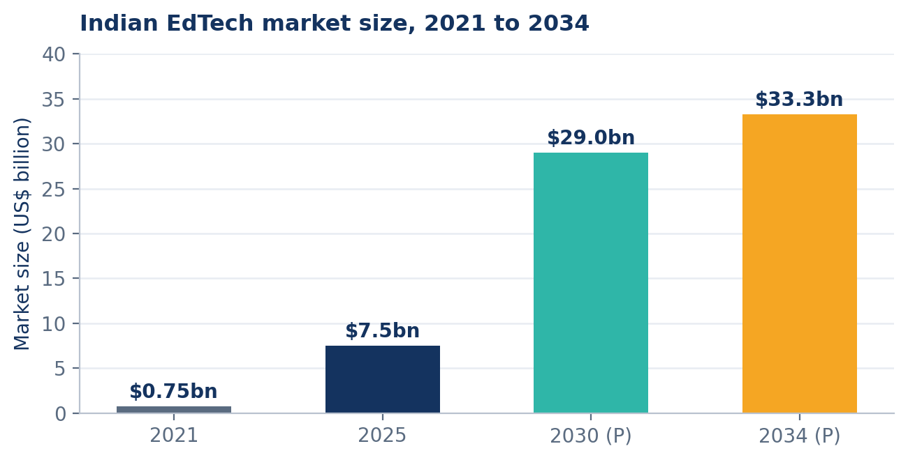
Figure 1. Indian EdTech market size, 2021 to 2034 (US$ billion).
Source: IBEF, IAMAI-Grant Thornton and IMARC estimates

Two cautions belong with Figure 1. First, the 2030 and 2034 figures are projections, and projections in this sector have a poor record. Second, different researchers count different things: estimates for 2025 alone range from about US$3.6 billion to about US$12.75 billion, depending on whether corporate training, study-abroad services and free content platforms are included. The direction of travel is clear; the precise level is not.
Structure and main segments
The industry divides into five recognisable segments, which differ sharply in who pays, how large the market is, and how closely the segment connects to SDG 4.
- K-12 learning and test preparation. What it sells: Curriculum-linked lessons, doubt solving, coaching for JEE, NEET and board exams. Who pays: Parents, directly. Closeness to SDG 4: Medium. Serves children already in school and mostly those who can pay.
- Higher education and upskilling. What it sells: Degree tie-ups, professional certificates, job-linked programmes. Who pays: Working adults and employers. Closeness to SDG 4: Medium. Connects to targets 4.3 and 4.4.
- School solutions (B2B). What it sells: Learning platforms, assessment tools, school management systems sold to institutions. Who pays: Schools and state governments. Closeness to SDG 4: High. Reaches children who cannot pay individually.
- Teacher training and content services. What it sells: Professional development, lesson resources, in-service training. Who pays: Schools, states, foundations. Closeness to SDG 4: High. Directly serves target 4.c.
- Early childhood and foundational learning. What it sells: Pre-primary content, foundational literacy and numeracy programmes. Who pays: Parents, states, NGOs. Closeness to SDG 4: High. Directly serves targets 4.1 and 4.2.
Vidyanta operates in the last three segments. That choice is deliberate and it shapes everything that follows: a company that sells to schools and states is judged on learning outcomes by customers who can audit them, whereas a company that sells to parents is judged on marketing promises by customers who usually cannot.
Main Players
The competitive field has three tiers. At the top are the large consumer brands built during the pandemic boom, several of which have since restructured. In the middle are focused business-to-business players selling to schools, states and enterprises. At the base are several thousand small firms, non-profits and content studios, many of them regional.
- Physics Wallah. Core focus: Affordable test preparation, hybrid centres. Primary customer: Students and parents. Position relevant to SDG 4: Access through low price; concentrated on exam aspirants.
- Unacademy. Core focus: Live classes, competitive exams. Primary customer: Students and parents. Position relevant to SDG 4: Broad subject coverage; urban and exam-focused.
- Vedantu. Core focus: Live tutoring, K-12. Primary customer: Parents. Position relevant to SDG 4: Individual tutoring; limited public-school reach.
- upGrad, Simplilearn, Great Learning. Core focus: Professional upskilling and degrees. Primary customer: Working adults, employers. Position relevant to SDG 4: Serves targets 4.3 and 4.4 rather than school learning.
- Educational Initiatives, Convegenius, LEAD. Core focus: Assessment and school platforms. Primary customer: Schools and state governments. Position relevant to SDG 4: Closest competitive set to Vidyanta.
- Khan Academy India, Pratham, Rocket Learning. Core focus: Free or philanthropic foundational learning. Primary customer: Donors, states, communities. Position relevant to SDG 4: Strong equity focus; not commercially driven.
- YouTube and free creator content. Core focus: Free video lessons in many languages. Primary customer: Advertising. Position relevant to SDG 4: Enormous informal reach; no accountability for outcomes.
Free creator content matters more than it first appears. A large share of India's digital learning happens on free platforms rather than inside paid EdTech products, which means that any company claiming to advance SDG 4 has to explain what it adds beyond what a child could already get for nothing. For Vidyanta the answer is structure, assessment and teacher support: the parts free video cannot supply.
Growth drivers
- Demographics. India has roughly 580 million people aged 5 to 24. Even slow-growing per-learner spending compounds into a very large market.
- Cheap data and widespread smartphones. India had more than 886 million internet users in 2024, a majority of them rural, supported by some of the lowest mobile data prices in the world. Smartphone availability in rural households rose from about 36 per cent in 2018 to about 67 per cent in 2024.
- Policy pull. The National Education Policy 2020 restructured schooling around a 5+3+3+4 model, set foundational literacy and numeracy as a national mission through NIPUN Bharat, and targets a 100 per cent Gross Enrolment Ratio in school education by 2030. Public digital infrastructure such as DIKSHA gives private providers a distribution rail they did not previously have.
- Aspiration and a competitive job market. Middle-class expectations, the intensity of competitive examinations, and awareness of global standards continue to pull families towards paid supplementary learning.
- State procurement. State governments increasingly buy learning platforms and assessment systems at scale, converting what was a consumer market into an institutional one with longer contracts and larger volumes.
The problems the industry has not solved
Growth statistics tell only one half of this industry's story. The other half is the reason SDG 4 exists in the first place.
The first unsolved problem is retention beyond the elementary years. Enrolment is close to universal early on and then falls away. The Gross Enrolment Ratio stands at about 93 per cent at the primary level but drops to 77.4 per cent at the secondary level and 56.2 per cent at higher secondary. Roughly one in nine children still drops out at the secondary stage, and retention at higher secondary is below half.
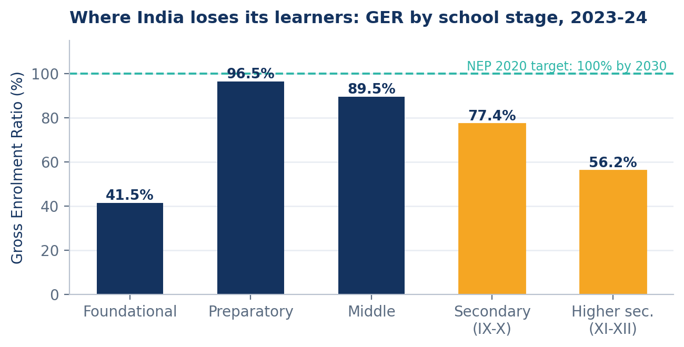
Figure 2. Gross Enrolment Ratio by school stage, 2023-24.
Source: UDISE+ 2023-24, Ministry of Education.
The foundational figure is low because it includes pre-primary years where enrolment is captured differently.
The second unsolved problem is learning itself. The ASER 2024 survey, covering 649,491 children in 17,997 villages, found that 23.4 per cent of Class 3 children could read a Class 2 level text. That is a genuine recovery from 16.3 per cent in 2022 and above the pre-pandemic level of 20.9 per cent in 2018: but it still means that more than three-quarters of children in Class 3 cannot read at the level of the class below them. At Class 5, 48.8 per cent could read a Class 2 text, roughly matching where the country stood in 2018. Basic subtraction among Class 3 children improved from 25.9 per cent in 2021 to 33.7 per cent in 2024.
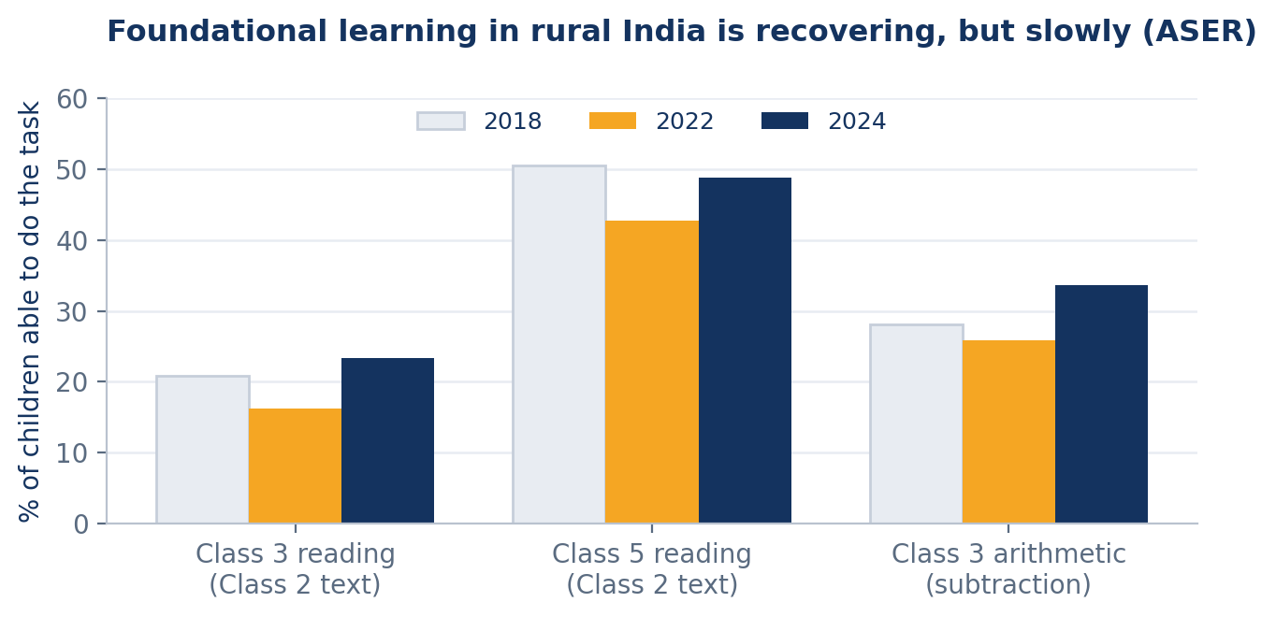
Figure 3. Foundational learning in rural India: % of children able to perform the task, 2018 to 2024.
Source: ASER 2024, ASER Centre.
The international comparison is no kinder. The World Bank estimates that 53 per cent of children in low- and middle-income countries cannot read and understand a simple story by age ten, and that at current rates of improvement the figure will still be around 43 per cent in 2030.
The third unsolved problem is digital capacity inside schools. Even in 2023-24, only about 57.2 per cent of schools had functional computers, 53.9 per cent had internet access, and 52.3 per cent had ramps with handrails for children with disabilities. Any EdTech product that assumes reliable broadband and a device per child has, by design, excluded roughly half the country's schools.
The fourth unsolved problem is trust. The sector's funding collapse after 2021 was driven partly by governance failures and by selling practices that pushed expensive loans onto low-income families. The Advertising Standards Council of India issued specific guidelines for EdTech advertising, and the industry formed the India EdTech Consortium as a self-regulatory response. A company entering this market today inherits that scepticism whether or not it earned it.
Policy and regulation
- National Education Policy 2020: Sets the 5+3+3+4 structure, prioritises foundational literacy and numeracy, targets universal Gross Enrolment Ratio in school education by 2030, and encourages the use of technology through the National Educational Technology Forum.
- NIPUN Bharat Mission: The national mission for foundational literacy and numeracy, which sets learning benchmarks for the early grades. It is the single most important policy anchor for a company working on foundational learning.
- Right of Children to Free and Compulsory Education Act, 2009: Establishes free and compulsory education for children aged 6 to 14 and sets norms including pupil-teacher ratios.
- Digital Personal Data Protection Act, 2023: Imposes strict requirements on processing children's personal data, including verifiable parental consent and a prohibition on tracking or targeted advertising directed at children. This constrains both product design and marketing.
- ASCI guidelines for EdTech advertising and the India EdTech Consortium code: Restrict claims about guaranteed results, require disclosure of loan terms, and set grievance-redressal expectations.
- Companies Act, 2013, Section 135 and SEBI's Business Responsibility and Sustainability Reporting framework: Together these make education spending and social disclosure a formal obligation for larger companies, and create the audience for the kind of reporting described later in this document.
PESTLE Analysis
Political- NEP 2020 implementation, state-level procurement of learning platforms, centrally sponsored schemes such as Samagra Shiksha. What it means for a company like Vidyanta: Government is becoming the largest single buyer. Credibility with officials matters more than consumer advertising.
Economic- Market growing from about US$7.5 billion in 2025 towards US$29-33 billion by the early 2030s, but after a severe funding contraction. What it means for a company like Vidyanta: Capital is available for firms with proven outcomes and real revenue, not for firms with only user growth.
Social- Strong family aspiration, persistent gender and regional gaps, rising rural smartphone access. What it means for a company like Vidyanta: Products must work in regional languages and on shared family devices, not only on a child's own phone.
Technological- AI-led adaptive learning, public digital infrastructure such as DIKSHA, but only about 54 per cent of schools with internet. What it means for a company like Vidyanta: Offline-first and low-bandwidth design is a requirement, not a feature.
Environmental- Growing scrutiny of device manufacturing, e-waste and data-centre energy use. What it means for a company like Vidyanta: Prefer refurbished and shared devices; report energy use honestly rather than claiming to be paperless and therefore green.
Legal- DPDP Act 2023 on children's data, ASCI advertising rules, RTE norms, CSR and BRSR disclosure duties. What it means for a company like Vidyanta: Marketing claims and data practices are both legally constrained. Communication must be verifiable.
Read together, the PESTEL factors point in a single direction. The Indian EdTech industry is moving from a consumer-marketing business to an institutional-trust business. In a consumer-marketing business, the loudest claim wins. In an institutional-trust business, the claim that survives an audit wins. That shift is the strategic reason a company in this industry should treat SDG 4 communication as core work rather than as public relations decoration

- Organisation Overview
Vidyanta Learning Private Limited is a hypothetical company created for this report. It has been designed so that the gap identified in the industry and SDG analysis, namely high enrolment, weak foundational learning, poor school connectivity and low institutional trust, is the gap its business exists to close.
Company snapshot
- Registered name: Vidyanta Learning Private Limited.
- Brand name: Vidyanta.
- Meaning of the name: From the Sanskrit vidya, meaning knowledge, and ananta, meaning without end.
- Tagline: Learning that reaches everyone.
- Founded: 2021.
- Registered office: Sector 44, Gurugram, Haryana.
- Regional offices: Lucknow, Patna, Bhopal, Ranchi and Guwahati.
- Legal form: Private limited company incorporated under the Companies Act, 2013.
- Business: Low-bandwidth learning software, assessment tools and teacher training for government and low-fee private schools.
- Employees: About 480, of whom roughly 210 are field and academic staff.
- Learners reached: About 1.2 crore across nine states (illustrative).
- Partner schools: About 31,000 government and low-fee private schools (illustrative).
- Revenue, FY 2025-26: About Rs. 214 crore (illustrative).
- SDG focus: SDG 4, Quality Education: targets 4.1, 4.4, 4.5 and 4.c.
The logo and what it means
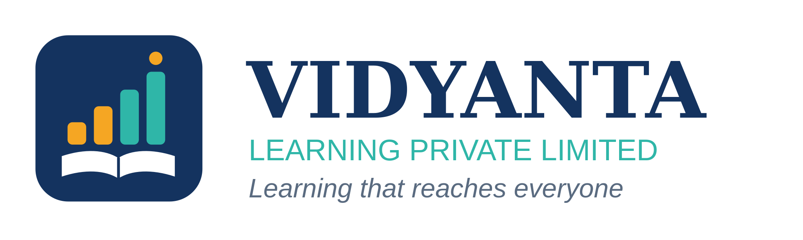
Figure 4. The Vidyanta logo
- A logo for a company making claims about learning has to do something more specific than look modern. Vidyanta's mark is built from three elements, each tied to a stated commitment, so that the visual identity and the SDG 4 message reinforce one another rather than sitting in separate departments.
- The open book at the base: Learning stays the foundation of the company. It is drawn open rather than closed, and it sits under everything else in the mark, because the technology is meant to serve the book rather than replace it.
- The four rising bars: These represent progress in measured learning levels, not user growth. The two amber bars stand for the foundational stage and the two teal bars for the middle and secondary stages, matching the four public pledges described in this section.
- The single amber dot above the tallest bar: It marks the child who is still out of reach: a deliberate reminder inside the identity itself that the work is not finished. In internal use it is called "the last child".
- Colours: Deep indigo for trust and institutional seriousness, which is the register the company's government customers work in. Amber for warmth and for the foundational stage. Teal for growth and for the digital product.
The mark works in three approved forms: the full horizontal lockup shown in Figure 4 for documents and websites; the badge alone for application icons and social profiles and a single-colour version for printing on low-cost material such as school notice boards and worksheets, which matters because a large share of the company's audience will only ever see it in black on newsprint.
What business we are in
- Vidyanta sells three connected things, and it is useful to state what it does not sell first. It does not sell coaching for competitive examinations, it does not sell degrees, and it does not sell direct-to-parent tutoring subscriptions at premium prices. Those are the most profitable segments of Indian EdTech and they are also the segments furthest from SDG 4.
- Vidyanta Setu, the core learning platform. An offline-first application for foundational literacy and numeracy in Classes 1 to 8, available in Hindi, English and six regional languages. It synchronises when a connection is available and works fully without one, because roughly half of Indian schools have no internet.
- Vidyanta Drishti, the assessment and analytics system. Termly assessments aligned to NIPUN Bharat benchmarks, with dashboards for teachers, head teachers, block officials and state departments. This is the product that generates the outcome data the company publishes.
- Vidyanta Shala, the teacher development programme. Blended training combining short digital modules with in-person block-level workshops, focused on how to use assessment data to re-teach rather than on how to operate the software.
The customer is usually an institution rather than a family. State education departments and district administrations buy at scale under multi-year contracts; low-fee private school chains license the platform per school; corporate and foundation funders support deployment in districts that cannot pay. A free tier is available to any government school in India without charge, which is both a genuine access commitment and, honestly, the company's most effective route into state procurement conversations.
Vision statement
“An India where no child's ability to read, count and reason is decided by the pin code she is born in.”
The vision is written as a description of the country rather than of the company, and this is deliberate. A vision that says "to be India's most trusted learning company" describes an ambition for Vidyanta. A vision that describes the condition of children describes the reason Vidyanta exists. The second is harder to reach and easier to be judged against, which is the point.
Mission statement
We build learning tools that work on the devices families already own and in the schools that connectivity has not reached, we train the teachers who use them, and we publish what children actually learn: including the years the numbers disappoint us.
The mission statement carries four working commitments, and each of them can be checked by an outsider.
- Build for the device and the school that exist, not the ones a product manager would prefer. Offline-first, low-bandwidth, multilingual, shared-device aware.
- Reach the children the market usually skips. Government and low-fee private schools in tier-2 and tier-3 districts, not metro private schools.
- Support teachers rather than route around them. Every deployment includes teacher training, and no product feature is released that a teacher cannot override.
- Publish outcomes, including bad ones. Learning-outcome data is released every year regardless of what it shows.
Core values
- Evidence before enthusiasm. If a claim cannot be measured, it is not made.
- The teacher is the customer, not the obstacle. Products that work by bypassing teachers do not survive in a school for long.
- Reach the last child first. Where resources are limited, they go to the district with the weakest baseline, not the one with the easiest sale.
- Plain language. Everything the company publishes, in every language, should be readable by a parent who left school at Class 8.
- Say the difficult number. When results fall, they are reported in the same place and format as when results rise.
Organisation structure
Vidyanta is organised as a flat functional company with five direct reports to the Managing Director. The structure is shown in Figure 5. One feature of it is relevant to this report specifically: Corporate Communication and ESG is a function in its own right, reporting to the Managing Director, with a direct reporting line to the Board's ESG and Impact Committee for all SDG 4 disclosures.
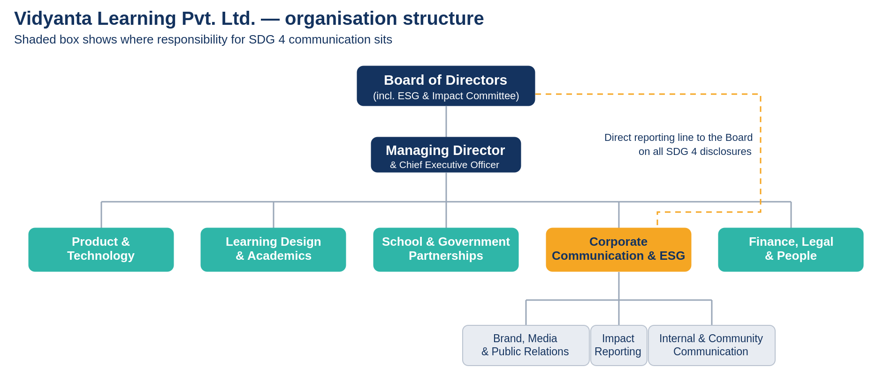
Figure 5. Vidyanta Learning Private Limited organisation structure.
The shaded box holds responsibility for SDG 4 communication.
That dotted line in Figure 5 is the governance safeguard that makes the anti-greenwashing rule described in the communication strategy enforceable. If the communication function reported only to the Managing Director, an impact claim could be softened or hardened for commercial reasons without anyone outside the executive team knowing. Because the function also reports to a Board committee, a decision to suppress a poor result would have to be taken in front of independent directors.
Business model and revenue mix
Vidyanta's revenue is deliberately weighted towards institutional buyers. Figure 6 shows the planned mix for FY 2027-28.
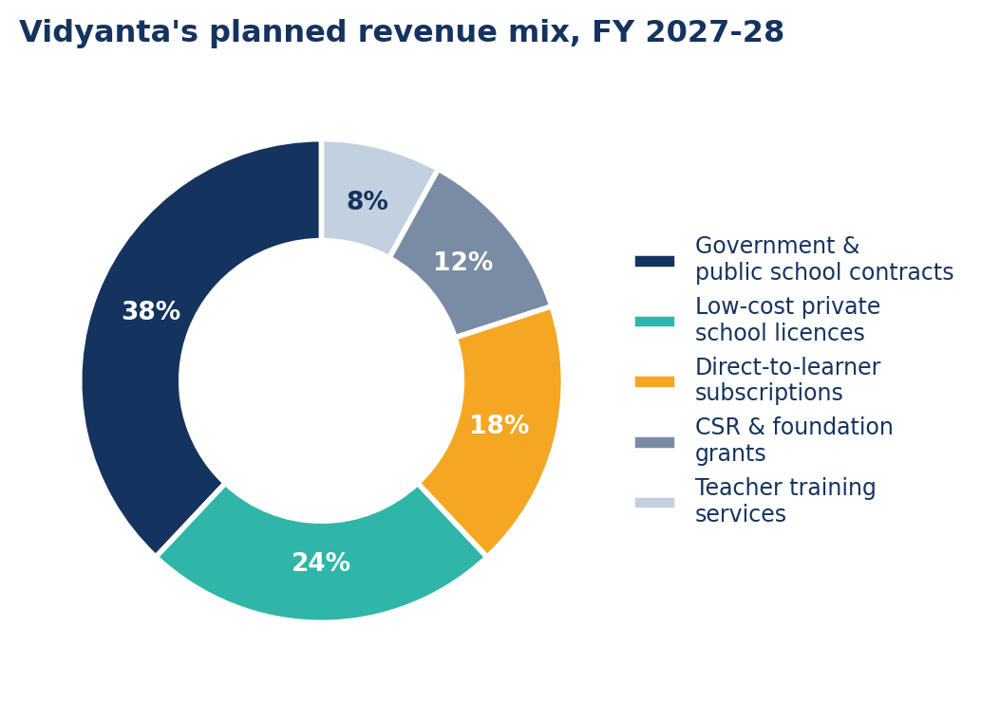
Figure 6. Vidyanta's planned revenue mix, FY 2027-28 (illustrative).
Roughly sixty-two per cent of revenue comes from government contracts and low-fee private school licences. Direct-to-learner subscriptions, which are the dominant model across Indian EdTech, account for only eighteen per cent here, and they are priced at a level intended to cross-subsidise the free government-school tier rather than to maximise margin. Grants make up twelve per cent and are used only for deployment in districts that cannot pay, never for core operating costs, so that a withdrawal of philanthropic funding cannot shut the company down.
This mix has a direct consequence for communication. When the buyer is a state department, the audience for the company's SDG 4 message is a procurement officer who will check the claims. When the buyer is a parent, the audience is someone who mostly cannot. Building the business around the first kind of buyer forces the communication to be verifiable: which is why the business model appears in a communication report at all.
How the business lines map to SDG 4
The link between the business and SDG 4 needs to be stated plainly. It is the link between what the company sells and what the goal asks for, and it is reproduced almost verbatim on the company website, in the annual impact report and in investor material, so that the same mapping appears everywhere.
- 4.1Quality primary and secondary education with real learning outcomes. Public pledge: By 2030, 80 per cent of children in our partner schools will read and do arithmetic at their grade level by Class 5. Business line that delivers it: Vidyanta Setu and Vidyanta Drishti. How it is measured: Termly assessment against NIPUN Bharat benchmarks, third-party sampled.
- 4.4 Relevant skills for work. Public pledge: Every partner school child in Classes 9 and 10 will complete a digital and employability skills module. Business line that delivers it: Secondary-stage skills modules. How it is measured: Module completion plus an end-of-module skills assessment.
- 4.5 Equity and elimination of disparities. Public pledge: 70 per cent of new deployments will be in aspirational and educationally backward districts, and girls will be at least half of all learners reached. Business line that delivers it: Go-to-market policy and free government tier. How it is measured: District classification data and gender-disaggregated reach reporting.
- 4.c Supply of qualified teachers. Public pledge: 40,000 teachers trained by 2030, with follow-up support for at least two terms after training. Business line that delivers it: Vidyanta Shala. How it is measured: Training completion, post-training classroom observation, teacher retention in programme.
Every pledge below has a number, a date and a measurement method. This is not decoration. A pledge without all three is a sentiment, and sentiments cannot be reported to a Board committee or audited by an assurance partner.

- Relevance of SDG 4
The Sustainable Development Goals in brief
The Sustainable Development Goals are seventeen goals adopted by all United Nations member states in 2015 as part of the 2030 Agenda for Sustainable Development. They replaced the earlier Millennium Development Goals and differ from them in three important ways: they apply to every country rather than only to developing ones, they cover environmental and institutional questions as well as social ones, and they explicitly invite the private sector to participate.
Each goal is broken into targets, and each target into indicators that are measured and reported. This structure matters for a company, because it means "supporting SDG 4" is not a slogan. It is a claim about specific numbered targets that have specific measurable indicators, and a company that names them can be held to them.
What SDG 4 actually asks for
SDG 4 reads: "Ensure inclusive and equitable quality education and promote lifelong learning opportunities for all." Beneath that sentence sit ten targets. Seven are outcome targets, numbered 4.1 to 4.7. Three are means-of-implementation targets, numbered 4.a to 4.c. Short descriptions of all ten targets are listed below.
- 4.1.: Free, equitable and quality primary and secondary education for all, leading to real learning outcomes. Does Vidyanta's business affect it?: Yes: directly, and this is the company's central claim.
- 4.2.: Access to quality early childhood development, care and pre-primary education. Does Vidyanta's business affect it?: Partly: through foundational literacy content for the preparatory stage.
- 4.3.: Equal access to affordable technical, vocational and tertiary education. Does Vidyanta's business affect it?: No: outside the company's scope.
- 4.4.: More youth and adults with relevant skills for employment and entrepreneurship. Does Vidyanta's business affect it?: Yes: through the secondary-stage digital and employability modules.
- 4.5.: Eliminate gender disparities and ensure equal access for the vulnerable. Does Vidyanta's business affect it?: Yes: the company's entire go-to-market is aimed at underserved districts.
- 4.6.: Universal youth and adult literacy and numeracy. Does Vidyanta's business affect it?: Partly: foundational content is used in some adult literacy programmes by NGO partners.
- 4.7.: Education for sustainable development, human rights, gender equality and global citizenship. Does Vidyanta's business affect it?: Partly: through curriculum content, but not a primary claim.
- 4.a.: Education facilities that are child, disability and gender sensitive, and safe learning environments. Does Vidyanta's business affect it?: Partly: through accessibility standards in the product, not through buildings.
- 4.b.: Expand scholarships for developing countries. Does Vidyanta's business affect it?: No: outside the company's scope.
- 4.c.: Increase the supply of qualified teachers, including through international cooperation for teacher training. Does Vidyanta's business affect it?: Yes: teacher training is a core business line.
Four targets have a direct link with the business: 4.1, 4.4, 4.5 and 4.c. Those four become the company's public pledges and the backbone of the communication strategy. The remaining six are not claimed. This restraint is itself a communication decision, and an important one: a company that claims all ten targets is telling its audience that it has not read them.
Where the world stands
Global progress on SDG 4 has effectively stalled. As of 2024, about 273 million children and young people were out of school worldwide: 79 million of primary school age, 64 million of lower secondary age and 130 million of upper secondary age. Since SDG 4 was adopted in 2015, that number has fallen by less than one per cent. It fell by a third between 2000 and 2015, then rose by about three per cent to 2024. In low-income countries the out-of-school population has grown by 29 per cent since 2015.
Money explains a large part of this. Low-income countries spent about US$55 per learner in 2022, against US$8,543 in high-income countries: a ratio of more than 150 to one. Four in ten countries spend less than four per cent of GDP on education, below the internationally recommended range.
The cost of inaction has been quantified. UNESCO estimates that children leaving school early and children lacking basic skills will together cost the world economy around US$10 trillion a year by 2030, a figure larger than the combined annual output of France and Japan. Set against that, each additional year of schooling raises an individual's income by roughly ten per cent on average.
Countries have collectively committed, through national benchmark targets, to cut the out-of-school population by 165 million by 2030. On present trends they will miss even that reduced ambition.
Where India stands
India's position is better than the global average on access and weaker than its own ambitions on quality. NITI Aayog's SDG India Index 2023-24 gave India a composite score of 71 out of 100 across all sixteen measured goals, up from 66 in 2020-21 and 57 in the 2018 baseline. Goal 4 scored 61, an improvement of four points, but still one of the lower goal scores and firmly in the "Performer" band rather than the "Front Runner" band. State variation is extreme: Bihar scored 32 and Odisha 40 on Goal 4, while Kerala, Himachal Pradesh and Tamil Nadu lead.
- SDG India Index score, Goal 4. Latest position: 61 out of 100 (2023-24), up 4 points. Source: NITI Aayog.
- Total school enrolment. Latest position: About 24.7 crore students (2024-25). Source: UDISE+.
- Schools and teachers. Latest position: About 14.7 lakh schools; teachers crossed 1 crore for the first time in 2024-25. Source: UDISE+.
- GER, primary. Latest position: About 93 per cent. Source: UDISE+ 2023-24.
- GER, secondary. Latest position: 77.4 per cent. Source: UDISE+ 2023-24.
- GER, higher secondary. Latest position: 56.2 per cent. Source: UDISE+ 2023-24.
- Dropout rate, secondary. Latest position: 14.1 per cent (2023-24), improving to 11.5 per cent (2024-25). Source: UDISE+.
- Class 3 children reading a Class 2 text. Latest position: 23.4 per cent (2024), up from 16.3 per cent (2022). Source: ASER 2024.
- Class 5 children reading a Class 2 text. Latest position: 48.8 per cent (2024), against 50.5 per cent in 2018. Source: ASER 2024.
- Class 3 children able to do subtraction. Latest position: 33.7 per cent (2024), up from 25.9 per cent (2021). Source: ASER 2024.
- Schools with internet access. Latest position: 53.9 per cent. Source: UDISE+ 2023-24.
- Rural households with a smartphone. Latest position: 67 per cent (2024), up from 36 per cent (2018). Source: ASER 2024.
Two conclusions follow from these figures, and both shape the company that this report builds. First, India's problem is quality, not access: a point NITI Aayog itself makes in explaining the Goal 4 score. Second, the digital rails now exist in households even where they do not exist in schools, which is why a product designed for a shared family smartphone reaches further than one designed for a school computer lab.
Why a company should care
There is a moral argument for corporate engagement with SDG 4, and it is a good one, but a report of this kind should also state the commercial argument plainly, because a commitment that depends only on goodwill will be cut in the first bad quarter.
- Market creation: A child who cannot read by Class 3 rarely becomes a paying customer for anything the education industry sells later. Foundational learning is the upstream condition for the entire market.
- Procurement access: State education departments increasingly require evidence of learning outcomes before awarding contracts. A firm that already measures and publishes outcomes is qualified before the tender is written.
- Cost of capital and investor demand: Impact-linked and ESG-oriented funds are among the most active investors in Indian education. Credible reporting widens the pool of available capital.
- Talent: Education companies compete for teachers, instructional designers and researchers who often had non-commercial options. A believable social purpose is a hiring instrument.
- Regulatory shelter: A company that voluntarily publishes verified outcome data is better placed when advertising standards tighten, as they have twice in this sector already.
- Risk reduction: The reputational damage suffered by parts of this industry after 2021 came from over-promising. A firm that defines success narrowly and reports it honestly has less distance to fall

- Achivements in SDG 4 so far
The figures in this section are part of the hypothetical company profile. They show what Vidyanta would report at the start of the proposed strategy. They should not be read as audited results from a real business.
Reach and access
By March 2026, Vidyanta has been introduced in about 31,000 government and low-fee private schools across nine states. Its programmes have reached roughly 1.2 crore learners. Most deployments are in tier-2, tier-3 and rural districts. The core government-school version is free, while state contracts, school licences and grants support implementation and teacher training.
- Regional access: The learning platform is available in Hindi, English and six regional languages. The same lesson can be downloaded at school and used later without a continuous internet connection.
- Low-bandwidth design: The application works on shared devices and stores progress until a connection becomes available. This responds directly to the fact that many schools still lack dependable internet access.
- Gender reporting: Learner reach is separated by gender and district. Girls account for about half of the learners reached in the current programme, which is the minimum expected under the equity pledge.
Learning and assessment
Vidyanta Drishti has moved the company away from counting only registrations and lesson views. Partner schools conduct short baseline and term-end assessments linked with NIPUN Bharat benchmarks. Teachers receive class-level results, while state officials receive district summaries. Public figures are reported in aggregate so that no child is identified.
The present data is not strong enough for the company to claim a nationwide learning effect. Coverage differs by state, and some schools have incomplete baselines. The honest achievement is that a measurement system now exists and can be checked. The next step is to improve consistency and allow independent sampling.
Teacher support
The Vidyanta Shala programme has trained about 12,000 teachers through short digital modules and block-level workshops. Training is followed by two terms of support through teacher groups, a helpline and school visits. Early feedback suggests that teachers value quick class summaries, but they dislike repeated data entry. The product team has therefore reduced the number of fields teachers must fill manually.
Governance and responsible communication
- Narrow SDG claim: The company links itself only with targets 4.1, 4.4, 4.5 and 4.c. It does not claim credit for the full SDG 4 agenda.
- Consent and privacy: Field stories require written consent. Learner pages do not carry advertising trackers, and public reporting uses grouped data.
- Correction record: The impact page keeps a visible record of corrections so that a changed number does not quietly replace an earlier one.
- Board oversight: Major impact claims go to the ESG and Impact Committee before publication. This gives the communication team a route to raise concerns if commercial pressure affects the wording.
What has not yet been achieved
Vidyanta has not yet completed an independent, multi-state evaluation of learning outcomes. It has also not reached every parent in a language they prefer, and the teacher-support model is uneven across districts. These gaps are included because a progress section should show unfinished work as clearly as completed work.

- Three-Year Plan to Advance SDG 4
The plan covers April 2026 to March 2029. The sequence matters. Vidyanta will first improve the quality of its evidence, then scale the programme, and only then make larger public claims. Growth without a reliable baseline would create impressive reach numbers but weak accountability.
Year 1: Build the baseline and public record, 2026-27
- Learning baseline: Complete comparable baseline assessments in all active districts and publish the method used to calculate learning gains.
- Website and dashboard: Launch the SDG 4 section, monthly dashboard, correction log and downloadable methodology note. The site will have a low-data version and a language switch.
- Teacher support: Train 9,000 additional teachers and provide follow-up for at least two school terms. Teacher feedback will be reviewed before each product release.
- Parent communication: Send termly progress messages by WhatsApp or voice to parents who opt in. Messages will explain one learning result and one practical next step.
- Independent assurance: Appoint an outside assurance partner to review the annual outcome report and the main public claims.
The first-year reach target is 3 crore learners. The more important target is completeness: at least 85 per cent of active schools should have a usable baseline and a term-end assessment.
Year 2: Scale with evidence, 2027-28
- District expansion: Increase reach to about 6.5 crore learners, with at least 70 per cent of new deployments in aspirational or educationally backward districts.
- Regional languages: Expand parent and teacher communication to twelve Indian languages, using native-speaker review rather than direct machine translation.
- Public data: Publish district-level results where sample quality is adequate. Where it is not adequate, mark the data as incomplete instead of filling the gap with estimates.
- Class 9 and 10 skills: Introduce digital and employability modules linked with SDG target 4.4, followed by a short practical assessment.
- Partner involvement: Invite NGOs, teachers and state officials to a yearly learning review. Their responses, including criticism, will be summarised in the impact report.
Year 3: Deepen outcomes and independent review, 2028-29
- Independent evaluation: Commission a multi-state evaluation comparing learning improvement across different implementation conditions. The full method and limitations will be public.
- Reach with quality: Move towards 11 crore learners while keeping teacher follow-up and assessment completion above the minimum quality threshold.
- Teacher community: Create district teacher circles that share classroom practices and help review product changes. Participation will remain voluntary and will not be used for teacher ranking.
- Accessibility: Add audio support, screen-reader testing, captions and accessible printable material for children and adults with different needs.
- Open learning resources: Release selected foundational resources under an open licence so that schools outside Vidyanta contracts can use them.
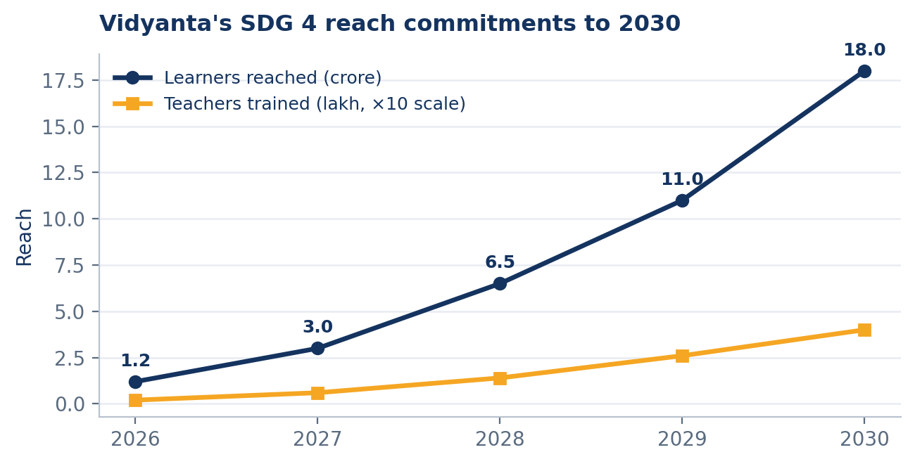
Figure 11. Vidyanta's SDG 4 reach commitments to 2030. The figures are illustrative company targets, not audited achievements.
Conditions that apply throughout the three years
No target can be treated as achieved only because the number of registered users has increased. Reach will be shown next to assessment completion, learning progress, gender balance, district coverage and teacher support. A weak result will remain visible in the same place as a strong one.
The plan also separates business growth from social claims. A new contract may be commercially successful before any learning result is available. Communication will state that difference clearly. Contract value, school activation and learning outcome are related, but they are not the same measure.
- Corporate Communication and Stakeholder Involvement Strategy
Stakeholder Analysis
Who our stakeholders are
A stakeholder, in Freeman's classic definition, is any group or individual who can affect or is affected by the achievement of an organisation's objectives. For Vidyanta, that definition produces eleven groups, which fall into three families.
- Internal stakeholders: Employees across the five functions; the Board of Directors and its ESG and Impact Committee.
- Connected stakeholders: Investors and lenders; state education departments and district administrations as customers; partner schools, head teachers and teachers; parents and learners as end users; NGO and foundation partners; suppliers and technology vendors.
- External stakeholders: Regulators including the Ministry of Education, ASCI and data-protection authorities; the media; industry bodies such as IAMAI and the India EdTech Consortium; and the wider public.
Two of these groups deserve a note. Teachers are formally low in power: they do not sign the contract and cannot cancel it: but they can quietly stop using a product, which ends a renewal as effectively as a cancellation. Parents and learners have almost no formal power in a business-to-government model and yet are the people the entire SDG 4 claim is about. A communication plan that allocates attention strictly by power would under-serve exactly the two groups that determine whether the claim is true.
Power and interest mapping
Mendelow's matrix sorts stakeholders by how much power they hold over the organisation and how much interest they take in a particular issue: here, the SDG 4 commitment specifically rather than the company in general. Figure 7 shows the result.
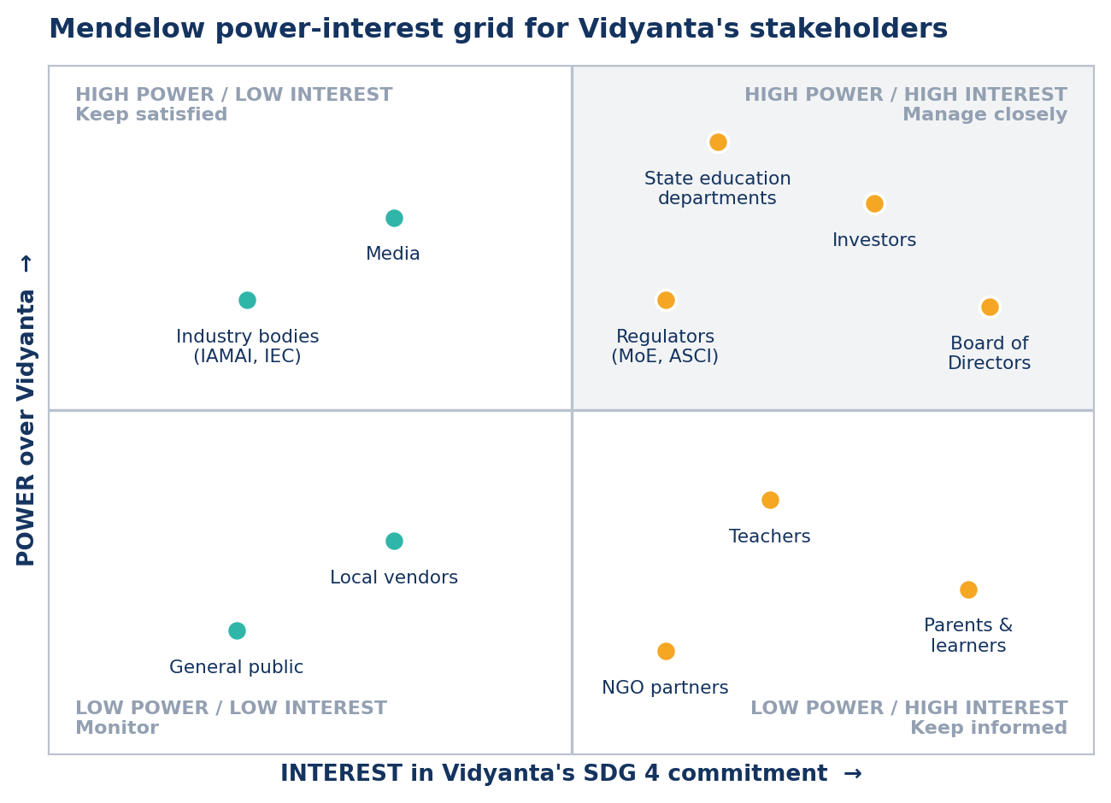
Figure 7. Mendelow power-interest grid of Vidyanta's stakeholders on the SDG 4 commitment.
- Manage closely (high power, high interest): state education departments, investors, the Board, and regulators. These groups receive detailed, data-heavy, individually addressed communication: quarterly reviews, assured impact data, direct briefings.
- Keep satisfied (high power, lower interest): media and industry bodies. These groups are given accurate material when they want it and are not flooded with it when they do not. The aim is that when they do turn their attention to the company, the record is already clean.
- Keep informed (lower power, high interest): teachers, parents and learners, and NGO partners. These groups get the largest volume of communication in absolute terms, in the simplest language, through the channels they already use.
- Monitor (lower power, lower interest): local vendors and the general public. Standard corporate disclosure is sufficient.
One deliberate departure from the standard prescription should be flagged. Textbook practice would place teachers and parents in "keep informed" and spend relatively little on them. Vidyanta spends thirty per cent of its communication budget on those two groups, in the proposed budget. The justification is that they are the only stakeholders who can make the SDG 4 claim true, and a claim that is well communicated upwards but not delivered downwards is precisely the failure mode this industry has already been punished for once.
What each stakeholder needs to hear
- Investors and lenders.
What they care about: Durable revenue, regulatory risk, ESG credentials. The message adapted for them: Measured learning outcomes are our competitive moat and our best defence against a tightening advertising regime. Main channels: Quarterly investor letter, annual impact report, data room, analyst briefings.
- Board and ESG Committee.
What they care about: Governance, accuracy of claims, exposure. The message adapted for them: Every published number has passed academic review and external assurance before release. Main channels: Quarterly Board pack, ESG Committee papers, internal audit report.
- State education departments.
What they care about: Verifiable results, alignment with NIPUN Bharat, value for public money. The message adapted for them: We report the same learning data to you that we publish to the world, on the same day. Main channels: Quarterly reviews, district dashboards, policy briefs, MoU reporting.
- Regulators.
What they care about: Truthful advertising, children's data protection, RTE compliance. The message adapted for them: Our claims are narrow, dated and evidenced; our data practices meet the DPDP Act. Main channels: Compliance filings, self-regulatory submissions, published policies.
- Head teachers and teachers.
What they care about: Workload, respect, whether the tool actually helps. The message adapted for them: This is built to give you back teaching time, and you can override anything it suggests. Main channels: Block workshops, WhatsApp teacher groups, printed handbooks, helpline.
- Parents and learners.
What they care about: Will my child learn, is it safe, does it cost anything. The message adapted for them: Free in your school, in your language, and you will get your child's progress every term. Main channels: WhatsApp broadcast, community radio, school notice boards, parent meetings.
- Employees.
What they care about: Purpose, clarity, pride in the work. The message adapted for them: Your target is a child who can read, not a download. Main channels: Town halls, intranet, induction, quarterly goal reviews.
- NGO and foundation partners.
What they care about: Shared outcomes, no duplication, honest reporting. The message adapted for them: We will publish joint results and name what did not work. Main channels: Partner reviews, joint reports, field visits.
- Media.
What they care about: A story that stands up, access to data and people. The message adapted for them: Here is the data, including the districts where we are behind. Main channels: Press releases, media kit, editor briefings, data downloads.
- Industry bodies.
What they care about: Sector reputation, self-regulation. The message adapted for them: We will support common outcome-reporting standards even where they constrain us. Main channels: Conference sessions, working groups, consultation responses.
- General public.
What they care about: Whether the company is honest. The message adapted for them: Look at the dashboard rather than the advertisement. Main channels: Website, social media, annual impact report.
Across these stakeholder messages, a single sentence is being said eleven times. That consistency is the test of a message architecture. If the investor version and the parent version cannot both be true at once, the architecture has failed, whatever the individual messages look like.
The Corporate Communication Strategy
Communication objectives
Objectives are set for one financial year, 2026-27, and each is written so that success or failure can be established at the end of the year rather than argued about.
Objective 1: Make the SDG 4 commitment findable. Measure: Share of website visitors who reach the SDG 4 page. Target by 31 March 2027: 12 per cent of all sessions.
Objective 2: Make the four pledges known internally. Measure: Employees who can name at least three of the four pledges, in an anonymous internal survey. Target by 31 March 2027: 85 per cent.
Objective 3: Make outcome data public and current. Measure: Impact dashboard updated within 10 working days of the close of each month. Target by 31 March 2027: 12 of 12 months.
Objective 4: Reach parents in their own language. Measure: Parents receiving at least one termly progress message in a language they chose. Target by 31 March 2027: 40 lakh parents.
Objective 5: Support teachers, not surprise them. Measure: Trained teachers who agree that the tool reduces rather than adds to workload. Target by 31 March 2027: 70 per cent agreement.
Objective 6: Earn third-party credibility. Measure: Independent media reports or policy citations referencing Vidyanta's published outcome data. Target by 31 March 2027: 25 in the year.
Objective 7: Keep claims clean. Measure: Upheld complaints against the company's advertising or impact claims. Target by 31 March 2027: Zero.
Objective 8: Report to the Board. Measure: Quarterly communication and impact review presented to the ESG Committee. Target by 31 March 2027: 4 of 4 quarters.
Objective 7 is the one that constrains every other. A target of zero upheld complaints is not an aspiration; it is a veto on any claim that cannot be defended, and it is the reason the verification step exists in the communication cycle described below.
The core message and the supporting messages
The plan uses one core message. Everything else in the architecture is a supporting message that must be consistent with it, and no channel is permitted to introduce a claim that does not appear here.
Core message: We only count a child as reached when that child can actually read, count and reason better than before.
M1: We name four targets, not seventeen. What it says: Vidyanta claims SDG 4 targets 4.1, 4.4, 4.5 and 4.c, and says nothing about the rest. Primary audience: Regulators, media, investors.
M2: We build for the school that exists. What it says: Offline-first, low-bandwidth, multilingual, works on a shared family phone. Primary audience: Governments, schools, parents.
M3: The teacher stays in charge. What it says: The product supports teachers and can always be overridden by them. Primary audience: Teachers, head teachers, unions.
M4: Free where it needs to be free. What it says: Any government school in India can use the core platform at no cost. Primary audience: Governments, parents, public.
M5: We publish the numbers we do not like. What it says: Learning-outcome data is released annually whatever it shows, with districts named. Primary audience: All stakeholders; the credibility anchor.
M6: We measure learning, not downloads. What it says: Reach is reported only alongside outcome data, never on its own. Primary audience: Investors, media, employees.
The communication cycle
Vidyanta's SDG 4 communication runs as a six-step cycle rather than as a series of campaigns. Figure 8 shows it.
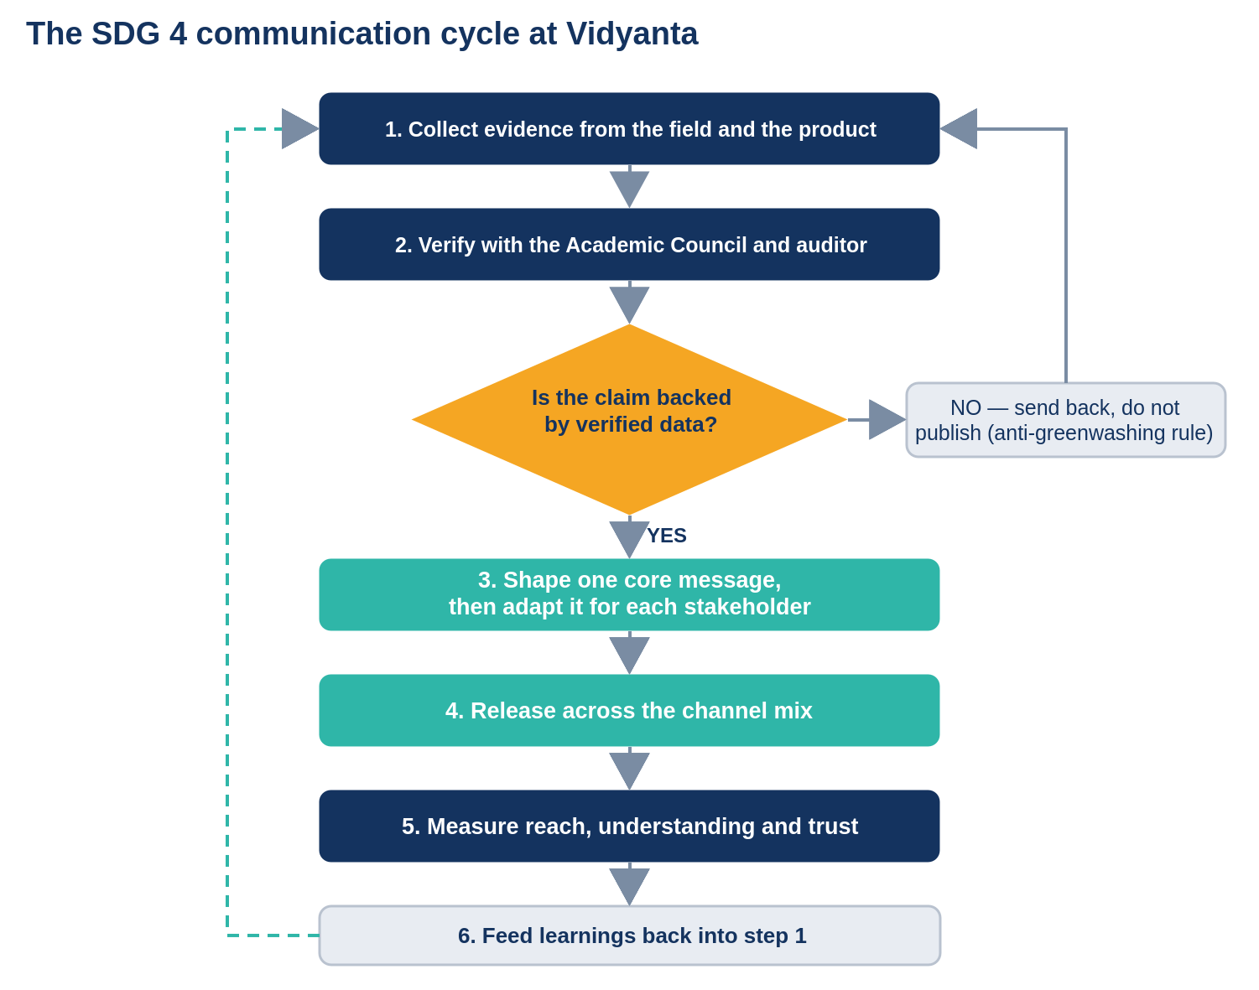
Figure 8. The SDG 4 communication cycle at Vidyanta, including the verification gate.
Step 2 and the decision diamond that follows it are the heart of the system. Before any impact claim leaves the company, the underlying data must be signed off by the Academic Council: a standing panel of four external education researchers: and, for anything published annually, by an external assurance partner. If a claim fails that gate, it goes back for more evidence; it does not get published in a softened form. This is the anti-greenwashing rule, and it is written into the communication policy rather than left to judgement.
The channel mix
The plan uses the paid, owned, earned and shared framework. The weighting is unusual for a company of this size: owned and shared channels carry most of the load, and paid media is used sparingly, because paid advertising is precisely the channel in which this industry lost its credibility.
- Owned: Channels used: Company website and SDG 4 page, impact dashboard, annual impact report, intranet, teacher handbooks, school notice-board posters, WhatsApp broadcast lists, IVR voice messages. Role in the SDG 4 plan: Carries the full message with no intermediary. The anchor of the entire plan. Share of effort: About 55 per cent.
- Shared: Channels used: Community radio slots, teacher WhatsApp groups, parent meetings at schools, partner NGO networks, social media conversation. Role in the SDG 4 plan: Carries the message into places the company cannot reach directly, and brings feedback back. Share of effort: About 20 per cent.
- Earned: Channels used: Press coverage, policy citations, conference sessions, research partnerships, awards. Role in the SDG 4 plan: Third-party validation. Cannot be bought and is the most credible of the four. Share of effort: About 17 per cent.
- Paid: Channels used: Search advertising on education queries, limited regional-language print in launch districts, sponsored policy-journal pieces. Role in the SDG 4 plan: Used only for awareness at launch and for recruitment. Never used to make impact claims. Share of effort: About 8 per cent.
Tone of voice, language and accessibility
The company's communication standard is that a parent who left school after Class 8 should be able to read anything Vidyanta publishes for a public audience. That standard has practical consequences.
- Short sentences and ordinary words. "We check what children have learned every term" rather than "we conduct periodic formative assessment interventions".
- Numbers with a reference point. "23 out of 100 children in Class 3 can read a Class 2 story" rather than "23.4 per cent foundational literacy attainment".
- Nine languages as standard. English, Hindi, Bengali, Marathi, Telugu, Tamil, Odia, Assamese and Bhojpuri, with translation done by native speakers who teach, not by software alone.
- Voice as well as text. Every parent-facing message is available as a recorded voice note and through an IVR call-back number, because literacy cannot be assumed among the adults being written to about literacy.
- Accessibility built in. WCAG 2.1 AA compliance on the website, screen-reader labelling, adjustable text size, and a high-contrast mode; captions and transcripts on all video.
- No superlatives. The words "best", "number one", "revolutionary" and "guaranteed" are banned in company communication. The last of these is also an ASCI compliance matter.
Twelve-month communication calendar
- April. Anchor moment: Start of the academic year. Main activity: Launch of the refreshed SDG 4 page and the four pledges; all-employee town hall. Lead audience: Employees, schools.
- May. Anchor moment: Teacher summer training cycle. Main activity: Vidyanta Shala block workshops; teacher handbook distribution. Lead audience: Teachers.
- June. Anchor moment: Annual impact report. Main activity: Publication of assured learning-outcome data; press briefing; investor letter. Lead audience: Investors, media, governments.
- July. Anchor moment: State review cycle. Main activity: District dashboards shared with nine state departments; policy brief released. Lead audience: Governments.
- August. Anchor moment: Term 1 assessment results. Main activity: First termly parent progress messages by WhatsApp and IVR. Lead audience: Parents.
- September. Anchor moment: World Literacy Day, 8 September. Main activity: "The Last Child" campaign on foundational literacy; community radio series begins. Lead audience: Public, parents.
- October. Anchor moment: Half-year review. Main activity: Dashboard half-year update; half-year Board and ESG Committee review. Lead audience: Board, investors.
- November. Anchor moment: Children's Day, 14 November. Main activity: Learner voices series; school notice-board poster refresh. Lead audience: Parents, learners, public.
- December. Anchor moment: Industry conference season. Main activity: Conference sessions on outcome reporting standards; partner joint reports. Lead audience: Industry, NGOs.
- January. Anchor moment: ASER release window. Main activity: Independent data commentary; company results placed in national context. Lead audience: Media, policy audience.
- February. Anchor moment: Term 2 assessment results. Main activity: Second termly parent progress messages; teacher follow-up survey. Lead audience: Parents, teachers.
- March. Anchor moment: Financial year close. Main activity: Annual objectives scorecard published, including missed targets. Lead audience: All stakeholders.
The March entry is the one most companies would leave out. Publishing a scorecard that names the objectives the company failed to meet, in the same document as the ones it met, is what converts the calendar from a promotional schedule into an accountability schedule.
Communicating SDG 4 Through the Company Website
Why the website comes first
The website is treated as the anchor of the entire plan for three reasons. It is the only channel the company fully controls, so nothing is lost in translation by an intermediary. It is the channel every other channel can point to, which means a press release, a WhatsApp message and an investor letter can all be short if they end in the same link. And it is permanent and time-stamped, so a claim made in 2026 can still be checked in 2030: which is exactly what a commitment running to 2030 requires.
Website architecture
The site is organised so that the SDG 4 commitment is not buried in a corporate social responsibility sub-menu, which is where most companies hide it. It sits in the top-level navigation, third of five, between what the company does and its newsroom.
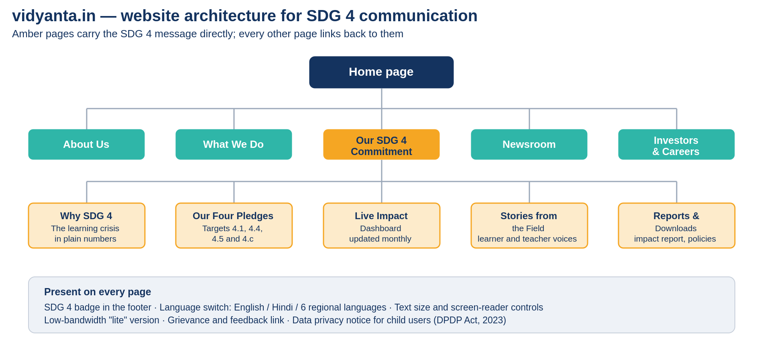
Figure 9. Website architecture for SDG 4 communication at vidyanta.in.

Page-by-page content plan
- Home: Banner carrying the core message; three live counters; a one-line link to the SDG 4 page; latest field story. Update cycle: Counters monthly; story fortnightly.
- Our SDG 4 Commitment: The goal explained in plain language, the four pledges, the mapping table, the verification process, and what the company does not claim. Update cycle: Reviewed quarterly, pledges annually.
- Why SDG 4: The learning crisis in numbers, sourced and linked, with global and Indian data side by side. Update cycle: Annually, on release of ASER and UDISE+.
- Our Four Pledges: One page per pledge: the target, the number, the deadline, the method, and the current position against it. Update cycle: Monthly with the dashboard.
- Live Impact Dashboard: Learners reached, learning gains by class and subject, teachers trained, district coverage, gender split; all downloadable as CSV. Update cycle: Within 10 working days of month close.
- Stories from the Field: Learner, teacher and head-teacher accounts, with consent, in text and audio. Update cycle: Fortnightly.
- Reports and Downloads: Annual impact report, assurance statement, methodology note, data protection policy, ASCI compliance statement. Update cycle: Annually, or on change.
- About Us: Vision, mission, values, leadership, governance, ESG Committee terms of reference. Update cycle: Annually.
- What We Do: The three products, each with a line on the SDG 4 target it serves. Update cycle: As products change.
- Newsroom: Press releases, media kit, spokespeople, high-resolution logo files. Update cycle: Continuous.
- Investors and Careers: Investor letters, BRSR-aligned disclosures, open roles carrying the mission statement. Update cycle: Quarterly.
Sample copy: home page banner
The following is the actual copy proposed for the home page banner, written to the language standard set in the language and accessibility plan.
Headline: A child in Class 3 who cannot read is not a statistic. She is the whole problem.
Sub-head: Vidyanta builds learning tools for schools that connectivity has not reached, trains the teachers who use them, and publishes what children actually learn. We support United Nations Sustainable Development Goal 4: Quality Education: and we name the four targets we are answerable for.
Live counters: 1.2 crore learners reached | 31,000 partner schools | 61 per cent of our Class 5 children reading at grade level, against a 2030 pledge of 80 per cent
Button: See where we are behind
The third counter and the button are the unusual choices. Most companies would show three rising numbers and a button reading "Learn more". Showing a figure that is nineteen points short of the pledge, and inviting the visitor to look at the shortfall, does more for credibility than any claim of leadership could.
Sample copy: the "Our SDG 4 Commitment" page
The full proposed text of the dedicated page follows. It is written to be read by a school head teacher, a journalist and a procurement officer without any of them needing a different version.
What Goal 4 asks for
In 2015, every country in the United Nations agreed to seventeen goals for the year 2030. The fourth one is about education. In full it says: ensure inclusive and equitable quality education and promote lifelong learning opportunities for all.
That sentence contains ten separate targets. We work on four of them. We do not work on the other six, and we do not claim to.
Why this matters in India
India has done the hard part of getting children into school. Almost every child of primary age is enrolled. But in 2024, only 23 out of every 100 children in Class 3 in rural India could read a story written for Class 2. At Class 5 the figure was about 49 out of 100. About one child in nine still leaves school during Classes 9 and 10.
India's own score on Goal 4, measured by NITI Aayog, is 61 out of 100. In some states it is in the thirties. The gap is not about buildings or enrolment any more. It is about learning.
Our four pledges
- Target 4.1: Learning, not attendance. By 2030, 80 out of every 100 children in our partner schools will read and do arithmetic at their grade level by Class 5. Today the figure is 61.
- Target 4.4: Skills that lead somewhere. Every child in Classes 9 and 10 in our partner schools will finish a digital and work-readiness module before leaving school.
- Target 4.5: The children the market skips. Seven out of every ten new school deployments will be in aspirational and educationally backward districts, and at least half of the children we reach will be girls.
- Target 4.c: Teachers first. We will train 40,000 teachers by 2030 and stay with each of them for at least two terms after the training ends.
How you can check us
Every number above appears on our impact dashboard, which is updated within ten working days of the end of each month. You can download the underlying data as a spreadsheet. Our annual figures are checked by an external assurance partner and by our Academic Council, which is made up of four education researchers who do not work for us.
If our numbers fall, we publish them anyway, in the same place and the same format. Our March scorecard lists the targets we missed as well as the ones we met.
What we do not claim
We do not claim to improve examination results, because we do not measure them. We do not claim that technology alone teaches a child; a trained teacher does, and our tools exist to give that teacher time and information. We do not claim to work on early childhood care, vocational education, scholarships or school buildings. Other organisations do that work, and some of them are our partners.
The live impact dashboard
The dashboard is the single element of the website that makes the rest of it credible, and it is worth describing in some detail because it is also the hardest to sustain.
- What it shows: Learners reached and how many of them were active in the last thirty days; learning gain by class and subject against NIPUN Bharat benchmarks; teachers trained and how many are still in the programme two terms later; district coverage against the aspirational-district commitment; gender split of learners reached.
- What it deliberately does not show: Downloads, app installs, hours spent, and video views. These are the metrics that made the industry's earlier claims meaningless, and excluding them is itself a message.
- How it is refreshed: Assessment data flows from Vidyanta Drishti, is aggregated monthly, passes the Academic Council check for anomalies, and is published within ten working days of month close. The publication date is shown on the page, so a stale dashboard is visible as stale.
- How it can be interrogated: Every chart has a download link giving the underlying data as a CSV file, and a methodology note explains the sample, the assessment instrument and the known limitations.
- Where it shows failure: Districts performing below the programme average are listed by name, with the current figure and the action being taken. This section is not collapsible.
Accessibility, language and data privacy
Three constraints shape the technical design of the site, and each is a communication decision as much as an engineering one.
Accessibility: The site meets WCAG 2.1 AA. Beyond compliance, a "lite" version loads in under three seconds on a 2G connection and under 300 kilobytes, because the audience most affected by SDG 4 is also the audience least likely to have a fast connection. A site about educational inequality that only loads on urban broadband would be an argument against itself.
Language: The site is available in nine languages, with the switch placed in the header rather than buried in the footer. Regional-language pages are not machine translations of the English original; they are written by native speakers with school teaching experience, and the SDG 4 page is reviewed by a teacher in each language before publication.
Data privacy: Because a large share of users are children, the Digital Personal Data Protection Act, 2023 applies in its strictest form. The site collects no behavioural data from child users, runs no advertising or tracking pixels on learner-facing pages, and publishes a plain-language privacy notice alongside the legal one. Progress messages to parents are sent on the basis of verifiable parental consent captured through the school, and the consent record is auditable.
Communicating SDG 4 Through Other Media
The media mix at a glance
The website carries the full commitment, but almost nobody in the company's most important audiences visits a website unprompted. Nine other media carry the message to them.
- Annual impact report: Audience: Investors, governments, regulators, media. Full assured data, methodology, assurance statement, missed targets. Frequency: Annual, June.
- Investor letter: Audience: Investors, lenders, Board. Progress against the four pledges framed as business risk and durability. Frequency: Quarterly.
- Press release and media kit: Audience: Journalists, policy writers. News-pegged results, spokespeople, downloadable data. Frequency: As events warrant, minimum quarterly.
- Employee town hall and intranet: Audience: All employees. Pledge progress, field stories, the internal scorecard. Frequency: Monthly intranet, quarterly town hall.
- Teacher handbook and block workshops: Audience: Teachers, head teachers. What the pledges mean in a classroom, how to read the data. Frequency: Handbook annually, workshops termly.
- WhatsApp broadcast and IVR: Audience: Parents and learners. Termly progress for their own child, in their chosen language, by text and voice. Frequency: Termly, three times a year.
- Community radio: Audience: Rural households in nine states. The "Last Child" foundational literacy series, in local languages. Frequency: Weekly, twelve-week seasons.
- School notice boards and posters: Audience: Parents, teachers, visiting officials. The four pledges in one page, printable in single colour. Frequency: Refreshed twice a year.
- Policy briefs and conferences: Audience: Governments, industry bodies, researchers. Evidence on what improved learning and what did not. Frequency: Quarterly briefs, four conferences a year.
- Social media: Audience: Public, employees, potential recruits, media. Short data posts, field stories, dashboard links. Frequency: Three to four posts a week
Internal communication with employees
Internal communication comes first in sequence, not last. An employee who hears the company's SDG 4 commitment for the first time in a press release will not believe it, and will say so to the next journalist or customer who asks.
- Induction: Every new employee, in every function including finance and sales, spends one day in a partner school within the first month. The four pledges are covered in induction before any product training.
- Monthly intranet update: One page: where each pledge stands, one district that improved, one district that did not, and why.
- Quarterly town hall: The Managing Director presents the same scorecard shown to the Board, including missed targets. Questions are taken unfiltered and unanswered ones are published afterwards with dates.
- Goal linkage: Every team's quarterly goals name the pledge they contribute to. Sales targets are stated in schools reached in aspirational districts as well as in revenue.
- Internal language rule: Nobody in the company reports "users" in an internal review without reporting learning gain in the same slide. This is enforced by the review template, not by exhortation.
Communication with investors and the board
- Investors receive the SDG 4 story in the language of business durability rather than in the language of virtue, because that is the frame in which they can act on it.
- Quarterly investor letter: Two pages. Financial performance first, then progress on the four pledges, then a named risk. Impact is presented as a lead indicator of contract renewal, not as a separate charitable section.
- Annual BRSR-aligned disclosure: Even as an unlisted company, Vidyanta reports voluntarily against the Business Responsibility and Sustainability Reporting format, on the argument that a company planning a public listing should not have to learn disclosure discipline in the year it lists.
- ESG and Impact Committee papers: The Committee receives the assurance partner's management letter in full, including findings the company would prefer not to circulate.
- Data room discipline: The same numbers appear in the data room, the dashboard and the impact report. A discrepancy between them is treated as an incident and investigated.

Media relations: a sample press release
The following press release is written for the annual impact report release in June and illustrates the company's rule that a release must carry at least one uncomfortable fact.
PRESS RELEASE: FOR IMMEDIATE RELEASE
Gurugram, 12 June 2026
Vidyanta reports 61 per cent of Class 5 children in partner schools now reading at grade level, and names five districts where it is falling short
Company publishes third annual impact report with external assurance; pledges 80 per cent by 2030
Vidyanta Learning Private Limited today published its third annual impact report, covering 31,000 partner schools across nine states. The report finds that 61 per cent of children in Class 5 in partner schools can read and do arithmetic at their grade level, against 54 per cent when the company began measuring in 2024.
The company also named five districts in which learning gains were below the programme average for the second consecutive year, and set out what it is changing in each. "A report that only carries the good districts is an advertisement," said the Managing Director. "We would rather be asked hard questions about five districts than be trusted for the wrong reasons about all thirty-one thousand schools."
Vidyanta supports United Nations Sustainable Development Goal 4, Quality Education, and reports specifically against four of its ten targets: 4.1 on learning outcomes, 4.4 on skills for work, 4.5 on equity, and 4.c on the supply of trained teachers. The company has pledged that 80 per cent of children in its partner schools will read and do arithmetic at grade level by Class 5 by 2030, and that 40,000 teachers will be trained by the same year.
The context is a national one. India's score on Goal 4 in NITI Aayog's most recent SDG India Index was 61 out of 100, and the ASER 2024 survey found that 23.4 per cent of Class 3 children in rural India could read a Class 2 level text. Roughly half of Indian schools still have no internet connection, which is why the company's platform is designed to work offline.
All figures in the report have been assured by an independent assurance partner and reviewed by the company's Academic Council. The underlying data is available for download at vidyanta.in/impact.
Notes to editors: Vidyanta Learning Private Limited was founded in 2021 and is headquartered in Gurugram. It works with government and low-fee private schools in nine states and employs about 480 people. High-resolution images, the full report, the assurance statement and spokesperson availability are at vidyanta.in/newsroom. Media contact: Head of Corporate Communication, press@vidyanta.in.
Social media
Social media is used for repetition and for recruitment rather than for persuasion. Nothing is claimed on social media that is not already documented on the website, and every post carrying a number links to the dashboard.
- LinkedIn: Data posts against the four pledges, methodology explainers, policy commentary, hiring. Cadence: Twice a week.
- Instagram: Field photography with consent, learner and teacher voices, short explainers on SDG 4. Cadence: Twice a week.
- YouTube: Teacher training clips, the "Last Child" radio series as video, dashboard walkthroughs. Cadence: Fortnightly.
- X: Release announcements, data corrections, responses to sector debate. Cadence: As needed.
- WhatsApp channels: Term reminders, progress notices, helpline information in nine languages. Cadence: Termly plus alerts.
One rule governs all five platforms: a post reporting reach must carry an outcome figure in the same post. This prevents the slow drift, familiar across the sector, in which a company's public voice becomes a stream of user milestones while its learning data quietly stops being mentioned.
Communication with parents, learners and communities
This is the group with the least formal power and the greatest stake, and it receives the largest share of the communication effort in absolute volume. The design principle is that the company should reach parents where they already are, in the form they already use.
- Termly progress message: Three times a year, each parent receives a short message about their own child: what the child can now do, what the child is finding hard, and one thing to try at home. It is sent by WhatsApp as text and as a voice note, and by IVR call-back for households without a smartphone.
- Language choice at enrolment: The parent chooses the language at the time of school enrolment, and the choice is stored with consent. No parent is written to in a language they did not select.
- Community radio: A twelve-week series called "The Last Child", carried on community radio stations in nine states, explaining what foundational literacy means and what a parent can do in ten minutes a day. Radio is used because it reaches households with no smartphone at all.
- School notice boards: A single-page poster carrying the four pledges and the helpline number, designed to print legibly in one colour on cheap paper, refreshed twice a year.
- Parent meetings: Company field staff attend at least one school management committee meeting per partner school per year, present the school's own results, and take questions.
- Grievance line: A toll-free number and a WhatsApp line, staffed in nine languages, with published response times and a quarterly report on complaint volumes and resolution.
Communication with teachers and school leaders
Teachers are the group most likely to be alienated by an EdTech company's arrival, and the group whose quiet non-use can end a contract. The communication with them is built around one message: the teacher stays in charge.
- Block-level workshops: Two-day in-person workshops each term, run by trainers who have themselves taught in government schools. The workshop begins with what the data says about that block's children, not with a product demonstration.
- The teacher handbook: A printed handbook in the local language explaining the four pledges, how to read the class dashboard, and how to override any suggestion the system makes. It is printed because school connectivity cannot be assumed.
- Teacher WhatsApp groups: Moderated by the company's academic team, used for classroom questions rather than announcements. Company staff answer within one working day.
- Recognition rather than ranking: Teachers whose classes improve are recognised publicly; teachers whose classes do not are never named. Ranking teachers against one another is the fastest way to end honest data entry.
- The override promise, in writing: Every handbook and every workshop states that no feature of the product can be enforced against a teacher's judgement, and that the company will not report individual teacher usage data to district officials for disciplinary purposes.
Communication with government and partners
- Quarterly state reviews: Each partner state receives a review presenting district-level learning data, including districts where results have fallen, before that data appears anywhere else.
- The same-day rule: Data shared with a state department is published on the public dashboard the same day. This removes any suspicion that the company shows one set of numbers to officials and another to the public.
- Policy briefs: Four short briefs a year on what has improved learning in practice and what has not, written for officials rather than for academics, and released whether or not the findings favour the company's products.
- Memoranda of understanding: Every MoU with a state includes a clause committing both parties to publish outcome data, so that transparency survives a change of the company's own leadership.
- NGO and foundation partners: Joint reporting on shared programmes, with an explicit section on what did not work, and a standing agreement that either partner may publish the joint results independently.
The annual impact report
The annual impact report is the company's most substantial single piece of communication and the one that anchors the credibility of everything else. It is published every June and follows a fixed structure so that any year can be compared with any other.
- A one-page letter from the Managing Director naming the year's biggest failure before its biggest success.
- Progress against each of the four pledges, with the target, the previous year's figure, the current figure and the gap remaining.
- Learning-outcome data by class, subject, gender and state, with district-level detail in an annexure.
- Teacher training data, including how many trained teachers were still in the programme two terms later, which is a harder and more honest number than training completions.
- A methodology note covering the assessment instrument, the sample, the confidence intervals and the known limitations.
- The external assurance statement in full, unedited, including any qualifications.
- A section titled "Where we are behind", naming districts and stating the corrective action for each.
- The objectives scorecard for the year, showing every communication and impact objective as met or missed.
Crisis communication
A company that publishes numbers will eventually publish a wrong one, and a company working in schools will eventually face an allegation about a child's safety or data. The plan therefore includes a standing protocol rather than an improvised response.
- A three-hour acknowledgement rule: Any credible allegation is acknowledged publicly within three working hours, even when the facts are not yet established. The acknowledgement states what is known, what is not, and when the next update will come.
- A single spokesperson: The Head of Corporate Communication speaks for the company on process; the Managing Director speaks on substance. No one else comments, and this is stated in the employee handbook.
- Correction policy: If a published figure is wrong, the correction appears in the same place, at the same prominence, with the original figure retained and struck through rather than deleted.
- Data incident protocol: A children's data breach triggers notification to the affected schools and parents, the data protection authority, and the public dashboard within the statutory period, with no exception for reputational considerations.
- Rehearsal: The protocol is tested once a year with a simulated incident involving the Board, the executive team and the field organisation.
Measuring Whether the Communication Works
Communication is easy to measure badly. Counting press mentions or website visits tells the company how loud it has been, not whether anything changed. The measurement framework therefore sorts every indicator into one of four levels, and requires that the company never report a lower level without reporting the level above it.
- Level 1, output: what the company produced. Pages published, releases issued, workshops held. Necessary to track, worthless on its own.
- Level 2, reach: who received it. Website sessions, parents messaged, teachers trained, radio listeners.
- Level 3, understanding and trust: what the audience took away. Whether employees can name the pledges, whether teachers believe the tool helps, whether officials find the data credible.
- Level 4, behaviour and outcome: what changed as a result. Contract renewals, teacher retention in the programme, parent participation, and ultimately the learning data itself.
The KPI dashboard
- Output: Indicator: Dashboard updated on time. How it is measured: Publication date against the 10-working-day rule. Target 2026-27: 12 of 12 months.
- Output: Indicator: Policy briefs published. How it is measured: Count. Target 2026-27: 4 in the year.
- Reach: Indicator: Share of website sessions reaching the SDG 4 page. How it is measured: Web analytics. Target 2026-27: 12 per cent.
- Reach: Indicator: Parents receiving a termly progress message. How it is measured: Delivery logs by language. Target 2026-27: 40 lakh.
- Reach: Indicator: Teachers completing block workshops. How it is measured: Attendance records. Target 2026-27: 9,000 in the year.
- Understanding: Indicator: Employees able to name three of four pledges. How it is measured: Anonymous internal survey. Target 2026-27: 85 per cent.
- Understanding: Indicator: Parents who can state one thing their child has learned. How it is measured: Field survey, sampled. Target 2026-27: 60 per cent.
- Trust: Indicator: Teachers agreeing the tool reduces workload. How it is measured: Post-training survey at two terms. Target 2026-27: 70 per cent.
- Trust: Indicator: State officials rating the data credible. How it is measured: Quarterly review feedback form. Target 2026-27: Average 4.2 of 5.
- Trust: Indicator: Upheld complaints on advertising or impact claims. How it is measured: ASCI and internal grievance records. Target 2026-27: Zero.
- Behaviour: Indicator: Contract renewal rate with state partners. How it is measured: Contract records. Target 2026-27: 90 per cent.
- Behaviour: Indicator: Independent citations of Vidyanta data. How it is measured: Media and policy monitoring. Target 2026-27: 25 in the year.
Targets to 2030
The communication plan exists to serve a set of reach and outcome commitments that run to 2030. Figure 11 shows the trajectory the company has published.

Figure 11. Vidyanta's SDG 4 reach commitments to 2030 (illustrative). Teacher numbers are shown on a ten-times scale so that both series are visible on one axis.
Publishing a trajectory rather than a single 2030 number is itself a communication decision. It means the company can be judged annually rather than only at the end, and it removes the standard escape route of a distant target that nobody checks until it is too late to matter.
What the plan will cost
The communication budget for 2026-27 is approximately Rs. 4.2 crore, which is close to two per cent of illustrative revenue. Figure 10 shows how it is divided.
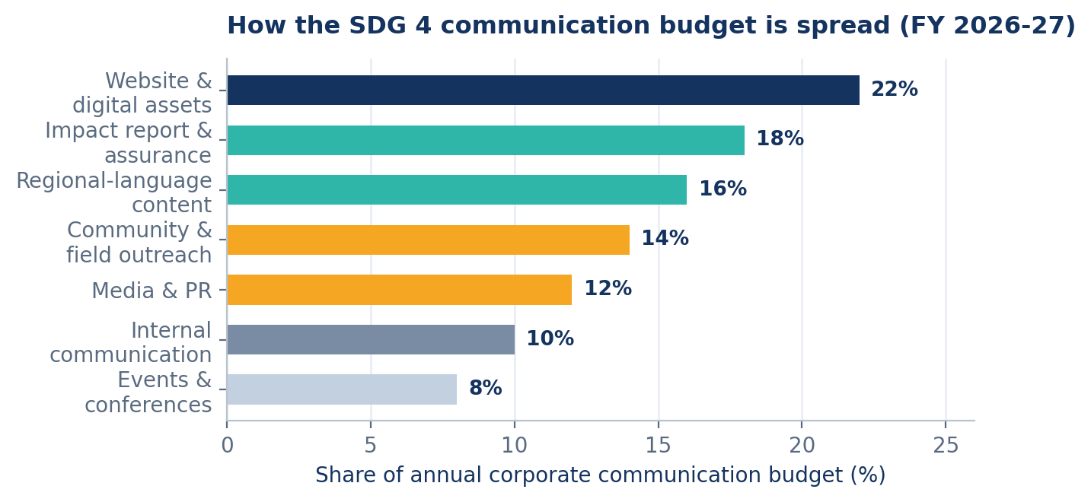
Figure 10. Share of the annual communication budget by head, FY 2026-27 (illustrative).
Two features of this split are worth noting. First, regional-language content and community field outreach together take thirty per cent of the budget: more than media, public relations and events combined. That allocation follows directly from the stakeholder-priority decision to over-invest in the low-power, high-stake groups. Second, eighteen per cent goes to the impact report and its external assurance. Assurance is expensive and produces no visible marketing asset, which is exactly why most companies skip it and exactly why it is the line item that makes everything else believable.
Assurance and reporting standards
- External assurance: An independent assurance partner reviews the annual learning-outcome data and issues a statement that is published in full, including qualifications.
- Academic Council review: Four external education researchers review methodology and any anomalous month before publication.
- GRI alignment: The impact report is prepared with reference to the GRI Standards, using GRI 413 on local communities as the primary disclosure for community impact.
- BRSR alignment: Voluntary reporting against SEBI's Business Responsibility and Sustainability Reporting format, in anticipation of listing requirements.
- UN Global Compact: The company reports annually through a Communication on Progress, which places its SDG 4 claims in a framework other companies are also judged against.
- Comparability rule: Once an indicator is published, its definition cannot be changed without a restatement of prior years, so that a target cannot be met by redefining it.
Risks, Challenges and How We Will Handle Them
A communication plan that does not name what could go wrong is an optimistic document rather than a working one. Eight risks are identified, ranked by the damage they would do to the credibility of the SDG 4 commitment.
- Greenwashing, or SDG-washing: Claims outrun evidence; the company is accused of using SDG 4 as marketing. Severity: Very high. How it will be handled: The verification gate in the verification step; naming only four targets; publishing failures; external assurance.
- Results fall and the company hides them: A bad year is quietly not reported, and the omission is later noticed. Severity: Very high. How it will be handled: Fixed annual publication date; the March scorecard; the Board reporting line that bypasses the executive.
- Teacher resistance: Teachers stop using the product; usage data stays flat while contracts remain live. Severity: High. How it will be handled: The override promise in writing; no individual teacher usage data to officials; recognition without ranking.
- Children's data incident: A breach or misuse of learner data under the DPDP Act. Severity: High. How it will be handled: Minimal data collection; no tracking on learner pages; the crisis communication protocol; annual rehearsal.
- Sector reputation damage by association: Another EdTech firm's scandal contaminates the whole category. Severity: Medium-high. How it will be handled: Consistent, boring, evidenced communication over time; support for common industry reporting standards.
- Language and literacy failure: Parent communication is technically delivered but not understood. Severity: Medium-high. How it will be handled: Native-speaker translation; voice as well as text; the Class 8 readability standard; sampled comprehension surveys.
- Message dilution: Different teams start making different claims as the company grows. Severity: Medium. How it will be handled: One core message and six supporting messages; a claims register; sign-off by Corporate Communication on all external material.
- Budget pressure in a downturn: Communication and assurance are cut first when revenue falls. Severity: Medium. How it will be handled: Assurance and dashboard costs are ring-fenced in the budget and approved by the Board rather than by management.
The first two risks share a root. Both arise when the reward for looking good exceeds the cost of being wrong. Every structural feature of this plan: the verification gate, the Board reporting line, the fixed publication date, the ring-fenced assurance budget: exists to change that balance, because a communication policy that depends on individual restraint will fail the first time restraint is expensive.

- Summary & Conclusion
Conclusion
This report set out to design a corporate communication system through which a company in the Indian education industry could carry the United Nations Sustainable Development Goal on quality education to every group with a stake in it. Four conclusions emerge.
First, the industry's problem has changed and the communication has not kept up. India has close to universal primary enrolment, more than 24 crore children in school and, for the first time, more than a crore of teachers. But fewer than a quarter of Class 3 children in rural India can read a Class 2 text, the Gross Enrolment Ratio falls to 56.2 per cent by the higher secondary stage, and India's Goal 4 score stands at 61 out of 100. A company that keeps reporting reach in a market where the binding constraint is learning is answering a question nobody is asking any more.
Second, SDG 4 is specific enough to be communicated honestly, and that specificity is an asset rather than a constraint. Because the goal breaks into ten numbered targets with defined indicators, a company can say exactly which four it affects and stay silent on the six it does not. Vidyanta claims 4.1, 4.4, 4.5 and 4.c. The restraint is what makes the four claims worth believing.
Third, one message can serve eleven audiences if it is true. The core message used throughout this plan: that a child counts as reached only when that child can read, count and reason better than before: works for an investor because it describes a durable competitive position, for a state official because it can be audited, for a teacher because it centres the classroom, and for a parent because it is the only thing she wanted to know. A message that has to be contradicted in one audience's version to work in another's is not a message architecture; it is a set of separate promises waiting to be compared.
Fourth, and most importantly, the credibility of the whole system rests on the willingness to publish inconvenient numbers. Every feature of this plan that a marketing team would object to: the home page counter showing a nineteen-point shortfall, the June report naming five failing districts, the March scorecard listing missed objectives, the assurance statement printed with its qualifications intact: is a feature rather than a concession. In an industry that lost more than ninety per cent of its funding partly because its claims outran its evidence, the ability to say a difficult number in public is not a reputational risk. It is the only durable reputational asset available.
The wider point is a simple one. Communicating a Sustainable Development Goal is not a matter of adding a coloured logo to a website footer. It is a matter of choosing which targets the business genuinely affects, building the measurement to know whether it is affecting them, and then telling everyone the answer whether or not the answer flatters the company. Done that way, SDG 4 communication stops being something the company says and becomes something the company can be checked on. That is the difference between a campaign and a commitment.

- Recommendations
Twelve recommendations follow from the analysis. Each names an owner and a deadline, because a recommendation without either is an observation.
1. Publish learning-outcome data annually regardless of what it shows, on a fixed date announced a year in advance. Owner: Managing Director and Board ESG Committee. By when: June 2026, then every June.
2. Name only the four SDG 4 targets the business affects, and remove any material claiming broader alignment. Owner: Corporate Communication and ESG. By when: April 2026.
3. Build the verification gate into the publishing workflow so that no impact claim can be released without Academic Council sign-off. Owner: Corporate Communication and Impact Reporting. By when: April 2026.
4. Make the SDG 4 page a top-level navigation item and place the impact dashboard one click from the home page. Owner: Product and Technology. By when: April 2026.
5. Ship the low-bandwidth "lite" website version under 300 kilobytes with a nine-language switch in the header. Owner: Product and Technology. By when: May 2026.
6. Give the Corporate Communication function a direct reporting line to the Board ESG Committee for all impact disclosures. Owner: Board of Directors. By when: April 2026.
7. Ring-fence the assurance and dashboard budget so that it cannot be cut by management in a downturn. Owner: Board and Finance. By when: At budget approval, March 2026.
8. Put the teacher override promise in writing in every handbook and workshop, and commit publicly not to share individual teacher usage data with officials. Owner: Learning Design and Academics. By when: May 2026.
9. Send every parent a termly progress message in their chosen language, as text and as voice, with an IVR fallback. Owner: Internal and Community Communication. By when: From Term 1, August 2026.
10. Adopt the same-day rule: any data shared with a state department appears on the public dashboard the same day. Owner: School and Government Partnerships. By when: July 2026.
11. Publish an annual objectives scorecard in March showing missed as well as met targets. Owner: Corporate Communication and ESG. By when: March 2027.
12. Rehearse the crisis protocol once a year with the Board, executive team and field organisation. Owner: Corporate Communication and ESG. By when: First rehearsal by October 2026.
If only one of the twelve is adopted, it should be the first. Everything else in this report is a mechanism for making an honest number reach the people who need it. The honest number has to exist first.

- Appendix
Appendix A: Stakeholder Feedback Questionnaire
The following instrument is administered annually to a sample drawn from each stakeholder group, to measure the understanding and trust indicators used in the measurement plan. Responses are collected in the respondent's chosen language, by field staff for parents and teachers and online for other groups. All items other than B1 and D3 use a five-point scale from "strongly disagree" to "strongly agree".
Section A: Awareness
- A1. Have you seen or heard anything from Vidyanta about the United Nations Sustainable Development Goals? (Yes / No / Not sure)
- A2. Can you name any specific commitment Vidyanta has made about children's learning? (Open response, coded against the four pledges)
- A3. I know where to find Vidyanta's learning-outcome data if I want to check it.
Section B: Understanding
- B1. In your own words, what does Vidyanta say it is trying to achieve by 2030? (Open response)
- B2. The language Vidyanta uses is easy for me to understand.
- B3. I understand how Vidyanta measures whether a child has learned something.
- B4. I understand which things Vidyanta says it does not do.
Section C: Trust
- C1. I believe the numbers Vidyanta publishes about children's learning.
- C2. I think Vidyanta would tell me if its results had fallen.
- C3. Vidyanta's claims match what I see in the schools I know.
- C4. Vidyanta treats teachers as partners rather than as a problem to be solved.
Section D: Behaviour and relevance
- D1. Because of something Vidyanta communicated, I did something differently. (If yes, what?)
- D2. I have shared information from Vidyanta with someone else.
- D3. How would you prefer to receive information from Vidyanta? (WhatsApp text / voice note / phone call / school meeting / radio / printed notice / website / other)
- Section E: Open
- E1. What is one thing Vidyanta says that you do not believe?
- E2. What is one thing you wish Vidyanta would tell you that it currently does not?
Item E1 is included deliberately and is reported to the Board verbatim rather than in summary. A stakeholder survey that cannot surface disbelief is measuring politeness rather than trust.

Appendix B: Sample Internal Town-Hall Script
The following is the opening section of the quarterly all-employee town hall, delivered by the Managing Director. It illustrates the internal language rule set out in the internal communication plan: the difficult number comes first.
"Good morning, everyone. Before I talk about the quarter, I want to put one number on the screen and leave it there while I speak.
Sixty-one. That is the percentage of children in Class 5 in our partner schools who can read and do arithmetic at their grade level. Our pledge for 2030 is eighty. So we are nineteen points short, with four years to go, and we are not on the straight line that would get us there.
Now the good news, and it is real. Two years ago that number was fifty-four. Seven points in two years, across thirty-one thousand schools, is not a rounding error. In Ganjam and in Sitapur the gain was more than twelve points, and I want the field teams in both districts to hear that named in front of the whole company.
But five districts have now been below the programme average for two years running. You will find them named on the intranet this afternoon, along with what we are changing in each. Nobody in those districts is in trouble. If naming a district got somebody into trouble, the next thing that would happen is that the data would stop being accurate, and then we would be a company that does not know anything about children while believing that it does.
Three things I want every person in this room to be able to say if a journalist, a customer or a cousin asks you this weekend. One: we work on four of the ten targets in Goal 4, and we can name them. Two: we count a child as reached when that child can read, count and reason better than before, and not before that. Three: we publish the number even in the years it goes down.
If you cannot say all three, come and find me afterwards, because that is my failure and not yours.
Now, the quarter."
The script is reproduced here because internal communication is the part of an SDG programme most often left to chance. An employee who has heard the difficult number said out loud by the Managing Director will repeat the commitment accurately. An employee who has only seen the campaign will repeat the campaign.

- References
ASER Centre. (2025). Annual Status of Education Report (Rural) 2024: National Findings. New Delhi: ASER Centre, Pratham Education Foundation.
Government of India, Ministry of Education. (2020). National Education Policy 2020. New Delhi: Department of School Education and Literacy.
Government of India, Ministry of Education. (2025). Report on Unified District Information System for Education Plus (UDISE+) 2023-24. New Delhi: Department of School Education and Literacy.
Government of India, Ministry of Education. (2025). Report on Unified District Information System for Education Plus (UDISE+) 2024-25. New Delhi: Department of School Education and Literacy.
Government of India, Ministry of Finance. (2025). Economic Survey 2024-25, chapter on human capital and education. New Delhi: Department of Economic Affairs.
Government of India, Ministry of Law and Justice. (2023). The Digital Personal Data Protection Act, 2023. New Delhi: Gazette of India.
India Brand Equity Foundation. (2025). Education and Training Industry in India. New Delhi: IBEF.
India Brand Equity Foundation. (2025). India's EdTech Market Likely to Reach US$29 Billion by 2030, citing the IAMAI and Grant Thornton Bharat report. New Delhi: IBEF.
IMARC Group. (2026). India EdTech Market: Size, Share, Trends and Forecast, 2026-2034. Noida: IMARC Group.
NITI Aayog. (2024). SDG India Index and Dashboard 2023-24: Fourth Edition. New Delhi: NITI Aayog, Government of India.
Press Information Bureau, Government of India. (2024). Release of SDG India Index 2023-24. New Delhi: PIB.
Press Information Bureau, Government of India. (2025). Ministry of Education Releases UDISE+ 2024-25 Report on School Education. New Delhi: PIB.
UNESCO. (2024). Global Education Monitoring Report 2024. Paris: United Nations Educational, Scientific and Cultural Organization.
UNESCO. (2024). The Price of Inaction: The Global Private, Fiscal and Social Costs of Children and Youth Not Learning. Paris: UNESCO.
UNESCO Institute for Statistics and Global Education Monitoring Report. (2025). SDG 4 Scorecard 2025. Montreal and Paris: UIS and GEM Report.
UNESCO. (2026). Out-of-School Rate: Global and Regional Estimates. Paris: UNESCO.
United Nations. (2015). Transforming Our World: The 2030 Agenda for Sustainable Development, Resolution A/RES/70/1. New York: United Nations General Assembly.
World Bank. (2022). The State of Global Learning Poverty: 2022 Update. Washington DC: World Bank, UNICEF, FCDO, USAID, Bill and Melinda Gates Foundation, in partnership with UNESCO.
World Bank. (2024). Learning Poverty Global Database. Washington DC: World Bank Data360.
Freeman, R. E. (1984). Strategic Management: A Stakeholder Approach. Boston: Pitman.
Mendelow, A. (1991). Stakeholder Mapping. Proceedings of the Second International Conference on Information Systems, Cambridge, Massachusetts.
All figures in this report were prepared by the group using data from the sources listed above. Company-specific figures relating to Vidyanta Learning Private Limited are illustrative and do not represent any existing organisation.
United Nations. Goal 4: Quality Education. https://sdgs.un.org/goals/goal4
ASER Centre. ASER 2024 National Findings. https://asercentre.org/wp-content/uploads/2022/12/ASER-2024-National-findings.pdf
Ministry of Education, Government of India. Education Statistics and UDISE+ reports. https://www.education.gov.in/en/statistics-new
NITI Aayog. India Voluntary National Review 2025. https://www.niti.gov.in/node/1806

